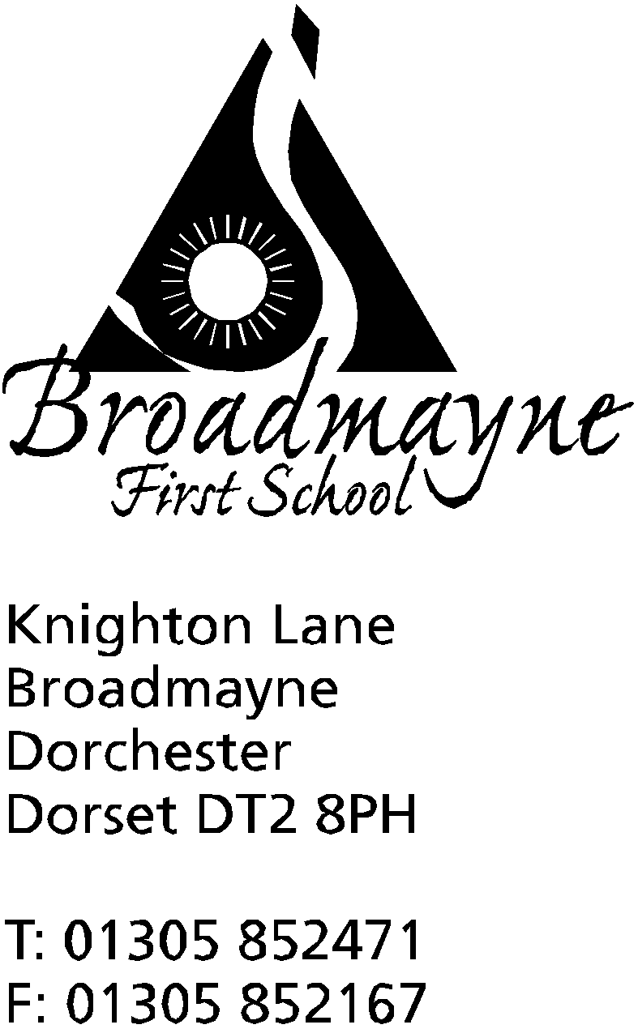

In Dorset

Headteacher
Helen Collings
Monday 13th July 2020

Dear Parents and Carers,

This will be the final newsletter of this academic year, and it feels very strange to be writing it in a school that is so quiet! It was wonderful to welcome back our Year 2 and 3 children last week - thank goodness the weather just about held out for us - and we can’t wait to see the Year 4 class this week - I hear rumours of a water fight at some point, but I’m sure that can’t possibly be true! Year 4 parents, Ms Carter has sent a separate email out to you all about the arrangements for this week, so please look out for it.

Our Return in September
We are really looking forward to coming back in September to full classes, and can’t wait to get back to our usual busy school life. Of course there will be some changes to how we operate at the beginning of the autumn term, but these should not impact negatively on our children. Using all available government guidance, we are planning on taking a similar approach to the one that has worked well for us over the past few weeks whilst we have had our key worker and Reception and Year 1 children with us. The most important points that you as parents and carers need to know are:
- Years 1 - 4 return to school on Wednesday 2nd September
- school uniform must be worn from September onwards
- The one way system we currently run for entering and leaving school will continue - this will be well sign posted and staff will be outside to guide you for the first few mornings!
- There will be staggered drop off and pick times in order to ensure families can social distance as necessary. The times and routes are as follows:

Drop off and pick up times
Class | Drop off | Pick up | Route
Reception | 8.45 - 8.55 am | 2.55 - 3.05pm from YR playground | Through car park following one way system
Year 1 | 9 - 9.10am | 3.05 - 3.15 pm from Secret Garden | Through car park to Y1 fire door, follow one way system
Year 2 | 8.45 - 8.55 am | 2.55 - 3.05pm from playground | Follow one way system, using Y2 /hall door
Year 3 | 9 - 9.10am | 3.05 - 3.15 pm from playground | Follow one way system using Y3/library door
Year 4 | 8.45 - 8.55 am | 2.55 - 3.05pm from playground | Follow one way system to Y4 fire door

- please send children in to school with PE kits, which can remain in school until half term
- there will be no hot school meals provided for at least the first four weeks of the autumn term - please either send your child in with a packed lunch, or one can be ordered via the Local Food Links website- we will inform you once we feel hot school meals are a viable option for us - please also see below for information about Local Food Links
- other than PE kit, bags, lunches and coats, we ask children not to bring anything else in to school
- Breakfast Club, Base Club and Cool Kids will resume on Monday 7th September, following their usual hours of operation - 7.45 - 8.45 am for Breakfast Club, and 3.15 - 6pm for Base Club/Cool Kids- please book during the first week back to school
- please do not send children in to school if they are showing any coronavirus symptoms - specifically a high temperature, a persistent new cough, a loss of taste or smell.

Our approach is very much to try and reflect how we see the world outside of school - our emphasis is on good hygiene and social distancing where appropriate, particularly between adults, rather than children. We will work to strike a balance between minimising risk for everyone at school, whilst also supporting our children’s, staff and families’ well being.
It is worth noting however, that all this is subject to change. The government will be making at least one more announcement about education and Covid-19 during the summer holidays, and it may be that I will have to change some of our plans in light of this. If this is the case, I will let you all know as soon as possible - and will write to remind everyone of our plans during the last week of the holidays!

Local Food Links
Local Food links have recently changed their website and ordering service. Kerry and Sally in the office are in the process of sending your new activation codes out to you - please let the school office know if you haven’t received one by this Friday, the 17th July.

Name Tags
The FABS have signed the school up to a really helpful website called My Nametags that produces name tags that can be used for school equipment and uniform. They are designed to withstand multiple washes and can stick to pretty much anything - very useful as we all know children have an astonishing capability to mislay a wide variety of things!
You can order online, by going to www.MyNametags.com using the School ID which is 35018. Please do not enter the school name instead of the ID code, as it will not recognise the school and we will not receive any credit.
The school will receive 24% of any money spent at the site.
The following link tells you a little more about the scheme: https://www.mynametags.com/static/img/downloads/MyNametags_fundraising_information.pdf

Staff Changes
We are sad to say that we will be saying goodbye to Carolyn Watson at the end of this term. Caroyln has been with Broadmayne for the past 9 years, and during that time has worked across many areas, including 1:1 support, classroom support and Speech and Language. Her contribution to our SEND work has been invaluable, and her calm approach and sense of humour has helped keep us all sane over the past few weeks! We will miss her a great deal, and send her off to the next stage in her career with our very best wishes.

As I finish this letter I want to take a moment to reflect on the changes we have all been through over the past few weeks. From the anxiety and uncertainty at the beginning of lockdown, through the weeks when we waited to see what would be happening next, we have all been on this journey together, although each of us will have experienced it in a different way. I know that many of us are looking forward to resuming a life that looks a little more ‘normal’. Please treat the summer holidays as a break-there is no expectation for you to be providing learning at home for your children (although please keep up with reading!) Once we are back in September we will all quickly fall into a familiar school routine and we have some wonderful plans in place to reconnect with our children and to re-engage them with learning at school.

Everyone at school wishes you all the best for the coming summer break. Keep safe and be kind to one another and yourselves - as parents and carers we need to sometimes stop and ensure we are looking after our own well being, as well as the people around us. If you are leaving us now as your children move on to middle school, we wish you all the very best for the future, and if you are staying with us, we can’t wait to see you all back here in September!

Yours faithfully,

Mrs Collings

Calendar Dates- Summer / Autumn Term 2020
Date | Time | Event
JULY
Wednesday 15th | all day | Transition day in school- Year 4
Thursday 16th | all day | Transition day in school-Year 4
Thursday 16th |  | LAST DAY OF SUMMER TERM FOR ALL CHILDREN
Monday 20th |  | INSET DAY
SEPTEMBER 2020
Tuesday 1st |  | INSET DAY
Wednesday 2nd | PM | First day of new academic year for Years 1-4  Transition afternoon for YR children-details to follow
Thursday 3rd | PM | Transition afternoon for YR children
Friday 4th | PM | Transition afternoon for YR children
Week beg.Monday 7th |  | New Reception children start Autumn term - details to follow

