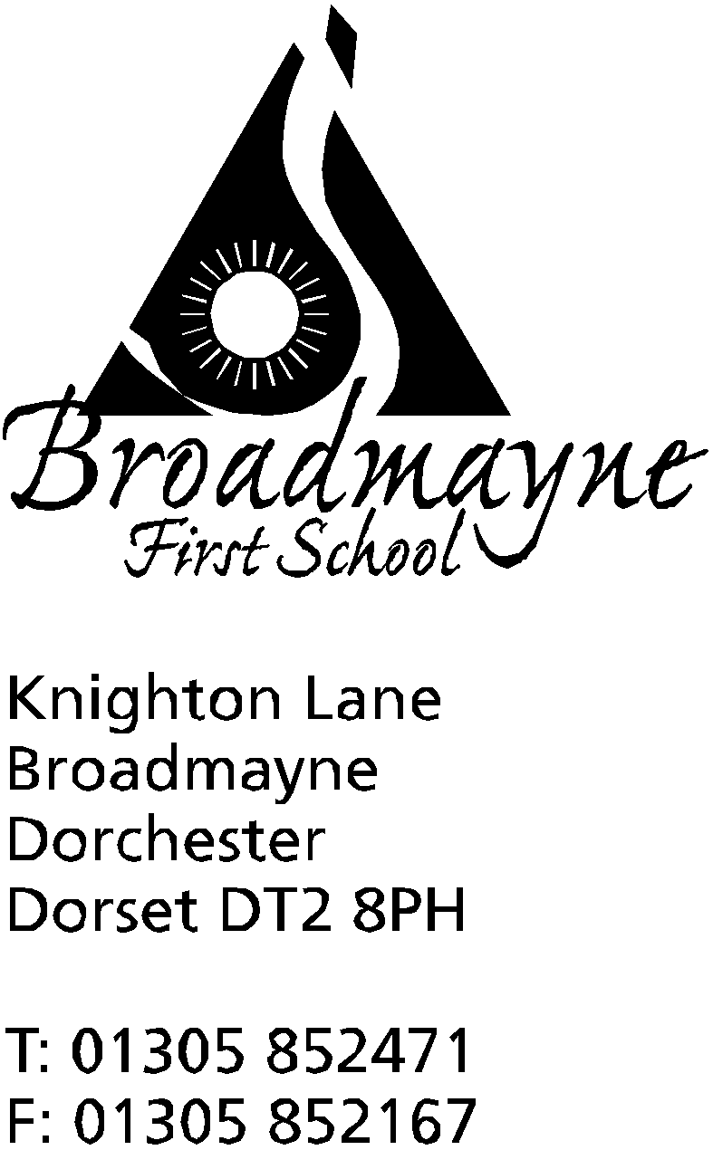

In Dorset

Head teacher
Mrs Helen Collings

Friday November 29th 2019

Dear Parents/Carers,

Christmas Play

The Christmas Play will be held on the 16th and 17th of December, with all performances being held in the school hall.
The play this year will be a traditional nativity, and will be performed by our Year 1 children, with narration by some of our Year 2 class. Children from the other classes will be singing in the choir. Spaces are limited due to fire safety regulations, and so we are operating a ticket system of two tickets per family. There is no charge for tickets, but we will be holding a collection at the end of the performance - this year we will be using the money to help fund further school performances and drama activities.

The performance dates and times are as follows:

Monday 16th December at 2pm
Tuesday 17th December at 9.30 am and 5pm

We will be offering a creche on the Monday afternoon performance - please book on the form below if you would like to make use of this.

Many thanks, and we look forward to seeing you at one of our performances,

Mrs Collings

School Christmas Performance 2019
Ticket Request - Please return by Friday 6th December 2019

Child’s Name: ……………………………………….……… Class: ……………………..

Parent’s Name: …………………………………………………………….

We would like our TWO tickets for:-
(Please tick below. You may split your choice i.e. 1+1. Apologies but only 2 tickets maximum per family)

Monday 16th December  2pm - School hall | Tuesday 17th December 9.30am - School hall | Tuesday 17th December  5pm - School hall

------------------------------------------------------------------------------------------------------------------------------------------

Christmas Play Creche

I would like to book a place at the crèche on (please tick)

- Monday 16th December from 1.45pm

Child’s Name: ……………………………………………. Age: …………..

Signed: …………………………………………………………. Parent/Carer

Please Print Name: ……………………………………………………...

Contact number: ……………………………………………………………..…

