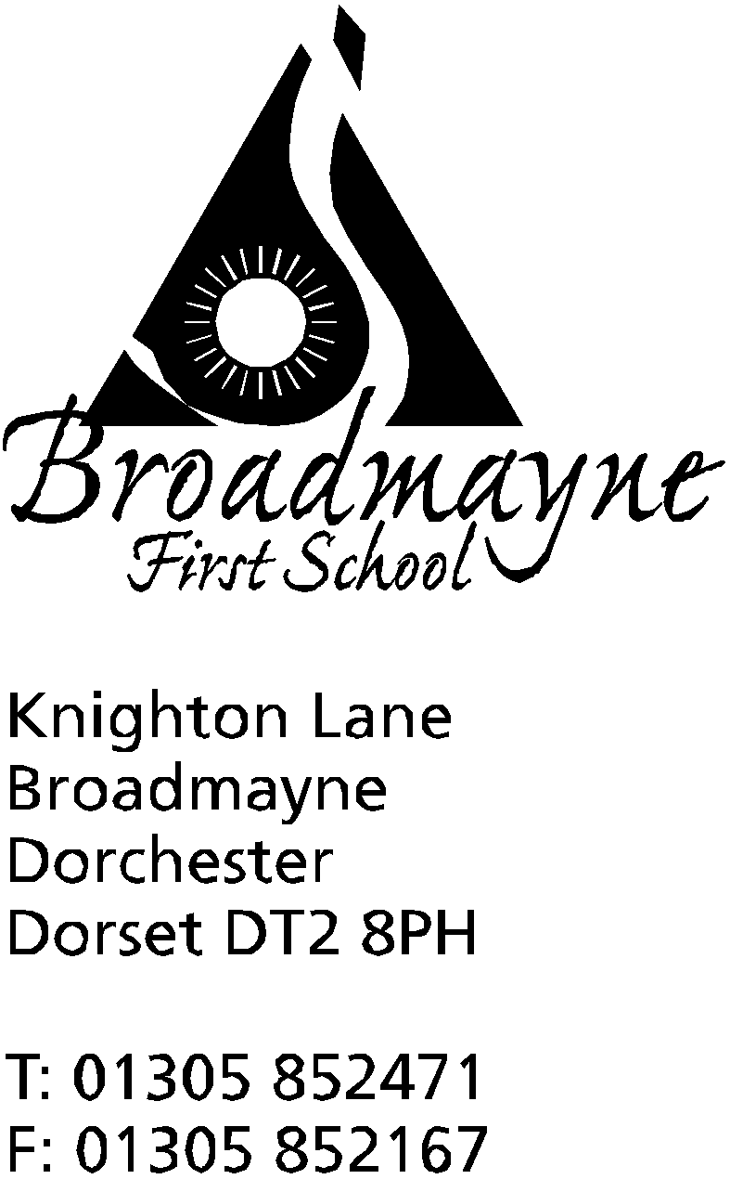

In Dorset

Headteacher
Helen Collings
Thursday 3rd September 2020

Autumn 2020: Newsletter number 2

Things to remember!
- Please ensure your child has a suitable, waterproof coat with them at all times, as we will be outside as much as possible
- The Strongman - theatre show being performed on Sunday 6th September on Broadmayne Playing Field - details below
- Book Breakfast Club/Cool Kids using the links below

Dear Parents and Carers,

I cannot begin to tell you how happy we all are to see our children back at school - I think both teachers and pupils are looking forward to getting some routine back into their lives! As we settle into the new school term there are bound to be questions and queries - we cannot think of everything that may come up, and I hope you all know that as a school we will react sensibly and thoughtfully to any new issue that arises. If there is anything that you want to bring up - a small question, something you have just thought of - please feel free to email Sally or Kerry in the office at office@broadmayne.dorset.sch.uk or myself at headteacher@broadmayne.dorset.sch.uk

Letters to Parents
During lockdown, we used email as the main means of communication with our families. This will continue into the new term. All letters will be sent via email - please ensure the school office has all relevant email addresses for you. There will be hard copies available from the office if you require one - please let the office know if this is ever the case and we can arrange to have one ready for you to pick up. We will also continue to use our text messaging service to keep you informed, and , of course our new Facebook page (see below for more details!)

New Covid-19 Guidance for Schools
You may have seen that the Department for education released the new guidance for schools returning in September at 9.30pm on Friday 28th August, the beginning of the bank holiday weekend, and three days before we were due to welcome our children back.
Having read through all new guidance, there are no changes we need to make to how we are currently planning on running the school - we will keep you informed of any major changes as they happen. There are a few things to bear in mind, in addition to the information in my letter last week:
- please do not come to the school office unless absolutely necessary - please contact us before doing so-most queries etc can be resolved via phone or email
- masks must be worn if you need to enter the school
- please do keep to the timings given for drop off and pick up - this enables you to social distance from other families as necessary, and allows staff to plan for the beginning and end of the day

Snacks - New playtimes
We are introducing a regular afternoon playtime for each year group. One of the things we noticed whilst we were open over lockdown was that our children are often very hungry by the afternoons, so if you would like to pack an extra snack for this time we are happy for the children to have these to keep them going throughout the day!
We encourage healthy snacks only for break times - this can include cheese, crackers etc and doesn’t need to be only fruit or vegetables. Years R to 2 will have fruit or vegetables provided as snacks for morning play-if your child is in Year 3 or 4 they will need to bring their own if they would like one then.
Please remember that our school operates as nut free - we have several children with severe allergies, so we are asking everyone to be mindful of this when preparing their children’s lunches and snacks.

Curriculum Information
Teachers will be sending out letters over the next week to inform you of some of the things that will be happening within your child’s class this term. We would normally invite you to a Curriculum Meeting for your child’s class, but obviously this year we are having to do things a little differently. For the time being we will share this information with you via email.

Home Learning and Google Classroom
Class teachers will be contacting you soon to share with you arrangements for Home Learning. We do not intend to set anything beyond the essentials for this for the foreseeable future - I would imagine many of you have had quite enough of learning at home for a while! For years 1-4 we will be using Google Classroom in order to ensure we all keep engaged with this platform, particularly in case there is ever a local lockdown in the future and we need to move to online learning again, or if we have groups of children having to self isolate. Please keep checking GC! Year 1 parents, Mrs Bassindale will send out a guide once she has the platform running in the classroom. Year R parents will have Tapestry as their means of communication, and please do remember that all staff have year group email addresses, should you need to contact them.
Year R - year-r@broadmayne.dorset.sch.uk
Year 1 - year1@broadmayne.dorset.sch.uk
Year 2 - year2@broadmyne.dorset.sch.uk
Year 3 - year3@broadmyne.dorset.sch.uk
Year 4 - year4@broadmayne.dorset.sch.uk

Breakfast Club and Cool Kids
Please book for both clubs via the following links:
- bookings for Breakfast Club can be made through the following form: https://forms.gle/BMX1ZKUmA8rn2krg7

- bookings for Cool Kids (which operates on a Thursday) can be made here: https://forms.gle/cP2A9XdUFKu9GJQM6

Artsreach Family Show in Broadmayne
This Sunday, the 6th September, there will be a family show called The Strongman held on Broadmayne Playing Field at 2pm. Performed by Bash Street Theatre, this will be a black and white street theatre show, with acrobatic circus skills, silent comedy and live music. After many months without live theatre this is a great chance to get involved again!
Tickets can be booked via www.artsreach.co.uk or bought directly from the Corner House Stores in Broadmayne. Tickets are £8, £5 for under 18s or £24 for a family ticket.

Astronomy Group
Your children may have been lucky enough to have had the opportunity to listen to Simon Beauchamp (father of Olivia in Year 4) talking about astronomy in one of his visits to school. His talks have been really well received by staff and children, and he is now hoping to encourage our older children to get involved in this fascinating hobby!
Simon is offering to provide an evening for Year 4 children and their families where we can see Saturn and Jupiter through a telescope. This will be held sometime in October - obviously it is highly weather dependent and so it is possible it will happen at fairly short notice. The venue is to be confirmed but is likely to be a site in Poundbury.
Simon is suggesting that if you are interested in getting involved with this he sets up a Whatsapp group to share more information. In order to do this, he will need your name and phone number - please use the form here to provide these details: https://forms.gle/XiVE9iysyuRfYQqE8
Simon will also be coming into school to work with our Year 1 children later in the Year, when they start their Space topic.

Broadmayne Facebook Page
In order to help our communication with our parents and carers, we have created a Facebook page for the school, which can be found here: https://www.facebook.com/broadmaynefirstschool
Initially I will be using the page to update you all with dates etc, but I plan to be able to share more information about what we are doing at school at some point soon.
Please bear with us as we get this page going - I am currently in charge of it, and whilst I love technology and am very confident at many aspects of it, I am not a prolific facebook user and am learning as I go!

FABS Fundraising
As you can imagine, the FABS have been wondering about ways in which they can safely continue fundraising for the school whilst we are all dealing with the implications of Covid-19. We would love to continue with our plans to refurbish our classrooms (Year 1 is looking lovely!), and there are various commitments that FABS help us with throughout the year. To this end, they are asking you all to consider the following suggestions to help them to continue in their fantastic work:

- Easy Fundraising
Go to the following website to sign up.
https://www.easyfundraising.org.uk/causes/friendsatbroadmayneschool/
You can download the app, or the add-on for your internet browser and can get cashback for FABS when shopping at eligible websites.

- Amazon Smile
Instead of going straight to amazon.co.uk, use the following link:
https://smile.amazon.co.uk
You log in to your normal amazon account then select a charity to support (search for FABS). FABS will then receive 0.5% on all purchases made via Amazon Smile.

- Splash Lottery
Better odds than the National Lottery with a guaranteed prize for a Broadmayne Supporter each week and an entry into the national jackpot draw where you could win £25,000. Tickets from £1 per week and all monies raised go directly to supporting the refurbishment and ongoing upkeep of the swimming pool.
https://www.yourschoollottery.co.uk/lottery/school/broadmayne-first-school
Every ticket that is purchased before the 12th September will also give you a chance to WIN a fantastic £500 forest holiday.

There are currently very few dates in our school calendar, as we approach the next few weeks cautiously. We expect the visiting music teachers to recommence during the week beginning September 14th, and will share more details of these with you once we receive them. We are not planning on running any after school clubs for the foreseeable future. However, we do expect school life to settle into a more recognisable routine as time goes on; we want to be sensible and careful as we reintroduce our more usual activities.

Please ensure you keep yourselves safe and continue looking after each other, as we look forward to the coming weeks

Yours faithfully,

Mrs Collings

Calendar Dates- Autumn Term 2020
Date | Time | Event
SEPTEMBER 2020
Thursday 3rd | PM | Transition afternoon for YR children-small group
Friday 4th | PM | Transition afternoon for YR children- small group
Week beg.Monday 7th | AM only | New Reception children start Autumn term  (F/T option available from Thursday 10th)
OCTOBER 2020
Monday 19th to Friday 30th |  | half term - 2 weeks
NOVEMBER 2020
Monday 2nd |  | Second half of Autumn term begins
DECEMBER 2020
Monday 21st to Friday 1st Jan |  | Christmas holidays
JANUARY 2021
Monday 4th |  | Return to school for beginning of Spring term

