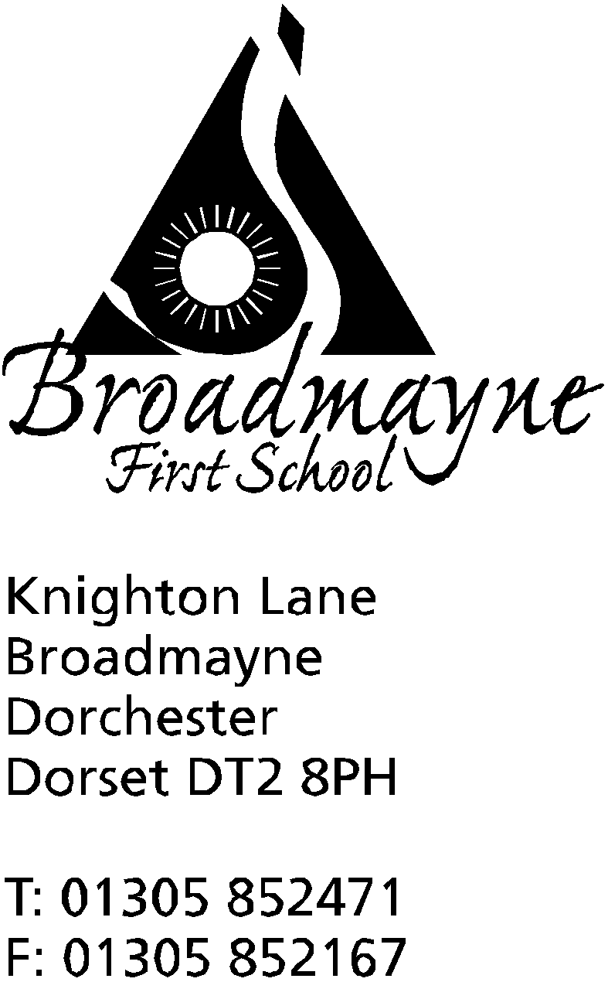

In Dorset

Headteacher
Helen Collings
Wednesday 18th November 2020

Autumn 2020: Newsletter Number 10

Things to remember!
- Have you completed the updated permissions for images - your child can’t be included in future filming if not! Link here:https://forms.gle/rcoM1rZjsAM4FAjm8
- Look out for emails from staff to organise any meetings you may have requested.
- FABS Auction link:www.easydonate.org/fabs-auction
- Thursday 26th November is the deadline to get your photo orders in!

Dear Parents and Carers,

As we begin to approach the mad rush toward the end of year, I’m afraid I am going to start mentioning the ‘C’ word - Christmas! We are having to prepare a little earlier than usual this year - many of Year 4 have already been dressed in their finest tinsel to take part in the recording of a new Christmas song, and plans for the Nativity are well under way! Please, please ensure you have completed our updated permissions - link above - otherwise your child will not be able to be included in any filming of events that we will be sharing via Youtube (including the Nativity performance). We have lots of plans to make the end of term as special as possible for our children, and will be sharing these with you in the near future.

Parking Around the School
We have been contacted by local residents who are really concerned about the parking around the school at drop off and pick up times, particularly around the top of Spring Gardens. Inconsiderate parking can be dangerous for road users and pedestrians alike, and we ask all our families to be mindful of this when coming to school. Please do not block lines of sight for exiting roads, or park across pavements or driveways. Please also be careful if you are reversing into a space - the rear end of vehicles can travel quite far onto the pavement and this can be very dangerous for our children. We know that parking is difficult at certain times of the day, but we need to work with our neighbours to keep everyone safe.

Covid Reminder
As a school, we know how difficult it is to keep up with the guidance on what to do if you have symptoms of Covid, or are asked to self isolate! Public Health England have endorsed a new, simple to follow guide, which is attached to the end of this letter, or can be accessed via the following link:
https://mailchi.mp/dorsetcouncil/latest-coronavirus-covid-19-news-and-information-17-march-3121566

Remembrance Day
We were so proud of our children’s response to Remembrance Day last week. From Reception to Year 4, they showed great respect as each class chose a slightly different way to commemorate this important time. Many thanks to everyone who contributed to our collection for the Poppy Appeal - unfortunately we don’t know how much we raised yet, as the boxes were sealed and sent straight to the appeal - we will let you know once we are informed.

Children in Need
We had great fun celebrating Children in Need last Friday, and the school looked very bright and cheerful with all the spots and stripes everywhere! The school raised £174 for this fantastic cause, and had lots of fun whilst doing so.

Playtimes
We are working hard to ensure our children are outside as much as possible at the moment. In order to ensure our bubbles are kept separate from each other, Years 3 and 4 are using the school field more than they usually would do at this time of year. The field does tend to get rather wet and muddy, and although the children know which areas they can access, they can get a little muddier than usual, particularly if they enjoy playing football! Thank you for supporting us with this - if you would like your Key Stage 2 child to bring in some suitable older shoes or trainers for playtimes we are happy to allow them to wear these.

Staffing Update
We are really pleased to welcome Alex Williams to the school. Alex comes to us with lots of experience in supporting primary aged children, and will be based mainly in Year 1, working with to support our younger children.

Dorset Families Magazine
Please see below for the link to the Dorset Families Magazine. In this Christmas issue you will find lots of activities that can be enjoyed at home with our young people - https://bit.ly/3nhSQWP

School Book Fair
Broadmayne is trying hard to help you with all your Christmas present buying needs this year! We are unable to have our usual ‘real life’ book fair in school, so instead have moved over to an online one instead! From Monday 30th November - Wednesday 2nd December you will be able to go online and browse and purchase books via the Facebook link here:
Book Fair for Broadmayne First School
If you do not use Facebook, you can access the event via the following link:
https://usborne.com/organiser/the_bookladydorset
Sam the event organiser, can then be emailed on usbornewithsam@yahoo.com. to make your book selection. Each book sold is not just a great gift for you, but also raises a little money for the school to also spend on new books.

FABS Update
The FABS Auction is now live! Have a look to find some brilliant ideas for Christmas presents this year, whilst also raising money for our children www.easydonate.org/fabs-auction

The FABS Facemask sales are proving to be really popular-look out for these in the playground - we will keep you updated by text!

Yours faithfully,

Mrs Collings

Calendar Dates- Autumn Term 2020
Date | Time | Event
NOVEMBER 2020
Week beg. 16th |  | NSPCC Speak Out, Stay Safe weekend Anti-Bullying Week
Monday 23 - Sunday 29th |  | Online auction for FABS - your Christmas shopping made easy!  www.easydonate.org/fabs-auction
Mon 30th - Weds 2nd Dec |  | Usborne School Book Fair  Book Fair for Broadmayne First School
DECEMBER 2020
Monday 7th |  | Filming for Nativity begins
Wednesday 16th |  | LFL Christmas Lunch
Friday 18th |  | Christmas Party Day and last day of Autumn term
Monday 21st to Friday 1st Jan |  | Christmas holidays
JANUARY 2021
Monday 4th |  | Return to school for beginning of Spring term

Thank you to parents and carers for following the guidelines that are in place to keep you, your child, your family and your school community safe. Here is an important reminder of the rules. Thanks to parents and carers for their support, it has been great to see children enjoying time together in class again.

Do not send children to school if they have symptoms of Coronavirus
You must not send your child to school if they have the following Coronavirus symptoms:
- High temperature
- Continuous cough
- Loss or change in sense of taste
- Loss or change in sense of smell
Here is more information from the NHS about Coronavirus symptoms.

Here is the guidance from Public Health Dorset about what you need to do if your child has symptoms of Coronavirus. There is also advice about what to do if your child is unwell with symptoms not related to Coronavirus.
Waiting for a test? You must self-isolate

If you or your child have symptoms of Coronavirus, your whole household must self-isolate immediately and book a COVID-19 test.

Your whole household must isolate until you get your test result back. If the test comes back negative then you can carry on your normal activities.

Self-isolation means that. You must not leave your house.

You may need family and friends to help you get essentials such as food or medication during the time you are isolating

What you must do if you or your child are ‘close contacts’

If your child has been classed as a close contact of a positive Coronavirus case, then they will be asked to complete 14 days of self-isolation from last contact with the confirmed case. This means they cannot leave home.

If you have other children at school then the child self-isolating cannot come with you on school runs either in the car or walking.

While your child is self-isolating you may need to ask family or friends to pick up your other children. If you are currently self-isolating as a close contact then you must arrange for friends or family to do the school run. You must not come to school or leave your home.

If you or your child develop Coronavirus symptoms then you must self isolate immediately and book a test.

