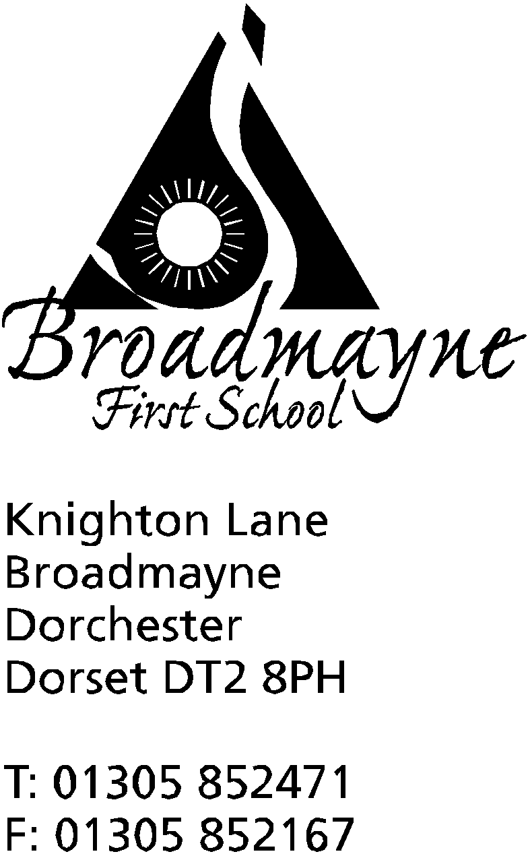

In Dorset

Head teacher
Mrs. Melanie Austin

12th July 2017

Summer 2017: Newsletter No. 6

Dear Parents and Carers,
As we come to the end of another wonderful year at Broadmayne I would like to thank all of our school community for helping to make Broadmayne such a special place. The staff, who work with such dedication and care, the FABs for their tireless fundraising, the governors who give so much of their time, the families for all their support and above all, the children who make it all worthwhile! We will be bidding a fond farewell to our lovely Year 4 class at the Leavers’ assembly and wishing them well for the next exciting step in their education. I hope all of you will have fun over the holidays and relax; the new school year will start on Wed 6th September for Yr 1- Yr 4. The new Reception class will start on Wed 6th or Thurs 7th, (am only), with the whole class on Fri 8th (am only).

Sports day & FABs fair
Thank you to the FABs and families for supporting our traditional sports day; we were lucky enough to have good weather but not quite so hot as the week before! The children were brilliant as always and I’m sure they appreciated all the encouragement from the spectators! The FABs raised over £600 which will be shared amongst the classes to buy more equipment- thank you so much.

Farewell
We are very sad to be saying goodbye to Mrs Gillott next week; luckily she will still be living in Dorchester so you may well bump into her and she has promised to keep in touch! We wish her happiness and success in her new job.
We are also saying goodbye to Miss Weeks who has been training this year in Year 4. We are very proud that she has now qualified as a teacher and will be taking up her post at Dunbury School. We wish her all the best and will miss her in September.

Thank you afternoon
We are looking forward to welcoming all our volunteers on Monday for an informal celebration, starting at 2.15. The children will be singing some of their favourite songs and serving refreshments.
If you have not received an invitation and have volunteered in school this year please let us know!
We will also be awarding some annual prizes and those parents will be invited too.

Art Showcase
Teachers have kept back some of the children’s lovely artwork for you to enjoy. It will be displayed in the hall on Tues 18th (9-11.30am & 3.30-4.15pm) so do pop in and have a look if you have time. Some pieces will be selected for display at the Broadmayne & West Knighton Arts Showcase in September.

Transfer Day
Feedback from children and staff has been very positive – all seems to have gone smoothly!

Governor vacancy
We have a vacancy for a parent governor. Please contact Mrs Foyle or Mrs Austin if you are interested in this role.

Swimming Gala/Sponsored Splash!
The FABs fundraising Sponsored Splash went ahead on Monday and it was a great success! We were very impressed with the determination of the children to do as many widths/lengths as they could- well done everyone! The FABs look forward to receiving some sponsorship donations towards the pool fund.

Library Summer Challenge: Animal Agents
On Mon 3rd July Helen from Dorchester library came to talk to the children about this year’s Summer reading challenge: “Animal Agents.” Leaflets have been sent home and we are hoping to exceed last
Year’s record!

School Reports
We are sending home our annual reports for your perusal this week. Yr 2 will be also sending SATs results and Yr 1 will send Phonics screening results. Depending on the year group and subject, teachers will be indicating whether children have attained Age Related Expectations/expected levels, exceeded/achieved greater depth, or are working towards. These assessments are based on National Curriculum objectives. Please come and ask if you have any queries.

Music lessons
Instrumental music lessons will start the week beginning 11th September

Summer swimming
Sarah Hewitt will be running her Turtlebacks swimming lessons during the first 2 weeks of the holidays (leaflets have been sent home) and FABs are hoping to run summer swimming throughout the holidays.

Ticks
I understand that there is a national increase in numbers of people getting tick bites this year- if you or your child are bitten please see a GP as soon as possible in case treatment is needed.

Yours sincerely

Diary dates

July
Thurs 13th 9.15 for 9.30am start | In-house football tournament-all welcome
Mon 17th at 2.15 | Thank you afternoon- invitations only
Tues 18th- am & pm | Art showcase in the hall- all welcome
Thurs 20th at 9.10 am | Yr 4 leavers’ assembly- Yr 4 families  Last day of Summer term
Fri 21st | Staff inset day

Dates for 2017-18 school year
Mon 4th and Tues 5th September: INSET days
Wed 6th September: First day of Autumn term for Yrs 1-4 and 1st half of Reception class
Thurs 7th September: 2nd half of Reception class
Fri 15th December: Last day of Autumn term
Half term: Mon 23rd- Fri 27th October inclusive
Other Inset days: Mon 30th October 2017, Friday 9th Feb 2018
5th Inset day to be confirmed

Spring term 2018
Friday 9th February: INSET day
Mon 2nd Jan to Fri 29th March
Half term: 12th-16th Feb

Summer term 2018
Wednesday 25th July: INSET day
Mon 16th Apr to Tues 24th July
Half term: 28th – 1st June

