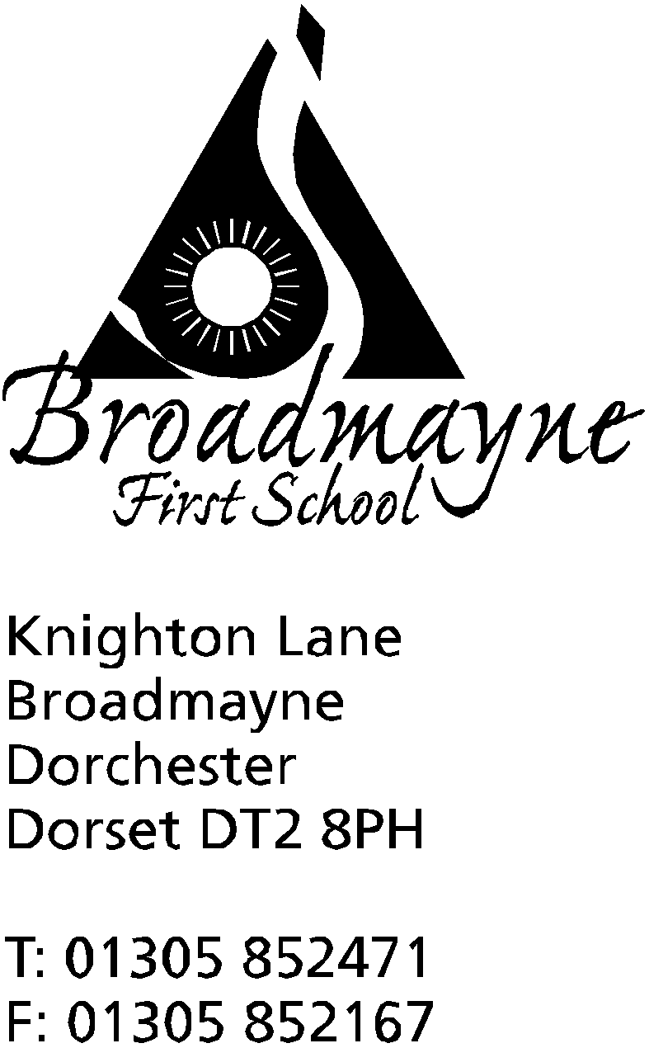

In Dorset

Headteacher
Helen Collings
Monday 16th December 2019

Dear Parents and Carers,

With the end of term fast approaching, I felt it would be a good time for us all to reflect on our achievements this term, and to look forward to some of the things planned for the beginning of 2020.

FABS Update
In addition to the Christmas Fair, FABS has had some wonderful success with grant applications and funding towards the swimming pool restoration programme. Back in April we gratefully received a grant award of £5,000 from the Community Foundation for Surrey’s Kaye Family Fund. An application to the Dorchester Market Car Boot fund resulted in a cheque for £500 for a new pool step ladder presented to FABS at Dorchester Town Hall. In October we applied to the Alice Ellen Cooper-Dean Charitable Trust based in Dorchester and were awarded an amazing £15,000 towards our pool project. Waitrose & Partners Community Matters scheme donated £429 to our cause and, in November, our Co-op Local Community Fund ended after a year of Co-op members supporting FABS and raising a whopping £4418.22 towards upgrading the pool environment. Finally, in December we have been awarded a £1000 grant towards the new pool toilet from Dorset Council’s Dorset Community Impact Fund. A big thank you to all our funders and supporters! Fundraising is still on-going, but we hope to start work next year.
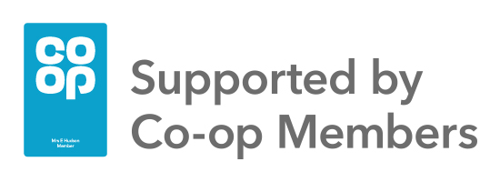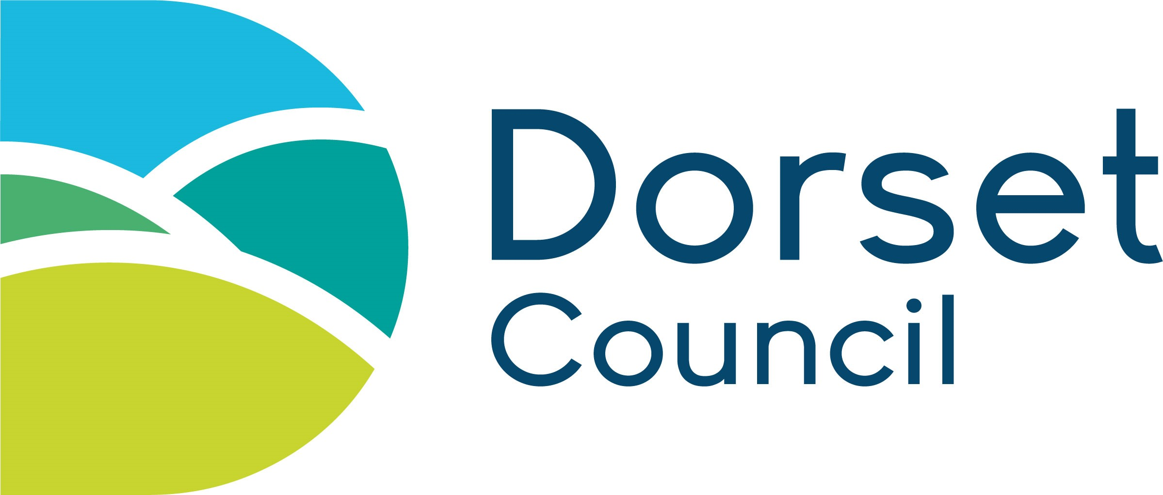
Wider School Community
Our regular ‘Read Alongside a Friend or Relative’ was a great success, with lots of members of the school community taking the time to come in and enjoy a variety of books with our children. We have also held very successful parent and carer workshops in supporting children's mental health, and we are planning to run at least one more of these next term.
It was lovely to see so many people attend our Harvest Festival celebration, and we were pleased to be able to send our donations to the local food bank.
Our Countryside Ramble was much enjoyed by all, and it was particularly appreciated that the weather was so good!
Thanks to the commitment of staff and parents, the defibrillator is already up and running, providing a much needed support for our school and the wider community.
Sports News
Mr Gibbons and Mrs Howells have worked together to support our sports teaching this term. We sent a team to the DASP First School’s Basketball tournament, and were very proud when they beat some excellent
opposition to come first. We have also had a team taking part in a Hi 5 festival (which is similar to traditional netball), which the children thoroughly enjoyed. We look forward to more events in the Spring Term,
including some training for our Year 4s in leading playground games.

Attachment Friendly Schools
As you may recall, the whole school is involved with training to become an attachment friendly school, beginning with whole school INSET training at the beginning of term. This training will continue into next year, and the parent workshops we have been offering are part of this school wide initiative. Next term we will offer further workshops, and I will be inviting parents to contribute to the creation of a new ‘Behaviour Regulation’ Policy.
Outdoor Area
We have continued to develop our outside areas. Thanks to a grant from the WPA Benevolent Association a clamberstack has replaced the older equipment in the adventure playground and the children have really enjoyed using it - we have just entered a bid for funding to further develop this area, which we should hear about in the new year.
Staffing
Sadly, Mr Oxlee will be leaving us at the end of term, although we are looking forward to welcoming Mrs Crumbleholme to Year 4 to cover Fridays for the next two terms.
ICT
We recently took delivery of a class set of Chromebooks which we will now be training all staff and children how to use. The next step will be for us to remove the old ICT suite, and to move the library to the centre of the school. By moving over to more mobile technology we aim to provide our children with the opportunity to see ICT as a useful tool for learning - and also to learn how to manage and control it carefully.
The Curriculum
The school has been using The Power of Reading to support our work in English this term, and we are really pleased with the impact this has had on teaching and learning across the school. Staff are very pleased with the way it puts quality children’s texts at the heart of planning, and more importantly, the children report that they are really enjoying the lessons!
Several staff from the school have been working with the Jurassic Maths Hub to further improve our delivery of a mastery maths curriculum, and we have all enjoyed developing our skills in this area.
Our science curriculum is going from strength to strength, and we are looking forward to developing this further in order to gain the Primary Science Quality Mark next year.
The first of our theme weeks - Safe and Healthy Me - was a great success, with a wide range of visitors and trips. In the New Year we are looking forward to other topic based weeks, which will be equally fun for everyone - the first of which is Collaborative Writing Week, followed by STEM Week, looking at Exploration and Discovery, and in the summer term Humanities Week with a focus on Dorset and the Jurassic Coast. There will also be an Olympics Week later on in the year.
Looking forwards...
Next term we are looking forward to improving the school even further. The library will be moving to the old ICT suite, putting books and reading right at the centre of the school whilst also freeing up some extra space for teaching and learning. The other exciting project will be run with the FABS. They will be working with us to refurbish one classroom at a time, with the idea of creating light, well organised and agile learning spaces for our children. Year 1 will be the first classroom to be replanned - further details will follow after Christmas!
Early in January, Mrs Stoker will be travelling to Nepal for a week to visit our friends at the AlteVetta project, and we look forward to strengthening our links with the girl’s school there. Mrs Stoker has a justgiving page if you are interested in donating - https://www.justgiving.com/crowdfunding/jostoker1 - donations will go directly towards supporting teaching within the school.

I would like to wish you all a happy holiday, and we look forward to seeing everyone, well rested and ready for the new year, on Monday 6th January.

Merry Christmas and a Happy New Year!

Mrs Collings

