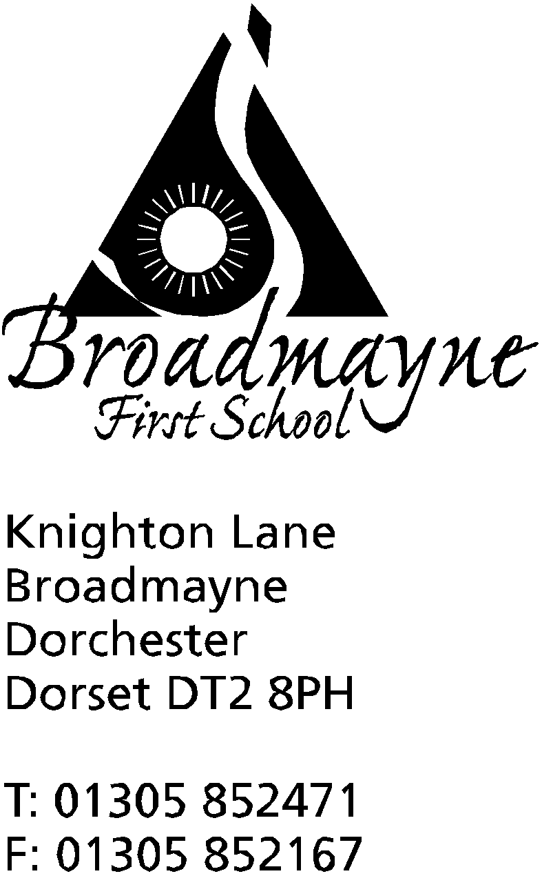

In Dorset

Headteacher
Helen Collings
Friday 16th October 2020

Autumn 2020: Newsletter Number 7

Things to remember!
- Trevor Senior’s lunchtime Football Club for KS2 children begins on Friday 6th November
- Clean, empty jam jars and plastic milk containers are needed for the FABS’ Bright Lights of Broadmayne (see the flyers with this email) - please save these over half term!

Dear Parents and Carers,

As we come to the end of the first half term I would like to say thank you to everyone who has supported our children’s return to school. It has been a really successful half term, and we are looking forward to returning in November, which is beginning to look like a busy and exciting month for us all!

Covid-19 update- wearing masks
We have been monitoring the increase in Covid-19 cases in the local area, and particularly the effect this is having on schools close to us. Broadmayne has made the decision that from Monday 2nd November, we will ask all adults accessing the school grounds to drop off or pick up children to wear a mask. We are not currently asking staff to wear masks when they greet children at the door, but this is under review. We hope this simple measure will provide an extra layer of protection for our staff and families.
We understand that there may be some people who cannot wear a mask, and we are happy to support you with this, but it is our expectation that the majority of parents and carers will be able to comply with this request.
Flu Immunisation
Today you will be receiving a letter via email to invite your child for the flu immunisation clinic which will be held in school on Monday 16th November. The letter will include a link to for you to give consent for the vaccination - children cannot be vaccinated without this consent, so please look out for this today.
Nut Free School
As you are aware, Broadmayne operates as far as possible as a nut free school. We had a very serious incident last week when one of our children ate something at home with peanuts in, and ended up with a stay in hospital. The item she ate was a cereal bar-we have found that nuts are often hidden within the ingredients of these and packages are not always clearly labelled. Please check the ingredients of food items sent in, particularly any cereal bars - we thank you for all your support with this and for helping to keep our children as safe as possible.
Dorchester History Booklet
Each family today will be receiving a history booklet called Let’s Explore Dorchester. It is a free magazine, aimed at children aged 5- 11. It contains lots of information about the local history of Dorchester and places such as Maumbury Rings, with activities for the children to complete. As history coordinator for the school, Mrs Bassindale would love to see any photos of the children visiting these places. You can email these in to your child's class teacher at their year group email.
Children in Need/Poppies
The school will not be able to sell poppies this year, due to the restrictions around Covid risk assessments. We have decided to instead hold Wear Red for Poppies day, on Friday 6th November. On the day we are inviting all staff and children to come into school wearing something red, and to bring a £1 donation for the poppy fund if they do so.
The following Friday, the 13th November, is Children in Need Day. We are inviting everyone to come into school wearing spots and/or stripes with a donation for the charity, and we will have some fun activities planned for the day.

We wish all our families a lovely half term holiday - we will keep our fingers crossed that the current good weather continues. We look forward to seeing you all, refreshed and recharged, on Monday 2nd November.

Yours faithfully,
Mrs Collings

Calendar Dates- Autumn Term 2020
Date | Time | Event
OCTOBER 2020
Monday 5th |  | Harvest donations for the local food bank welcome from today - please leave in the box by the school front door
Wk beg. 12th |  | Harvest Week
Monday 19th to Friday 30th |  | Half term - 2 weeks
NOVEMBER 2020
Monday 2nd |  | Second half of Autumn term begins
Friday 6th |  | Wear Red for Poppies - £1 donation
Tuesday 10th | 9am | School photographer visits to take pupil photographs
Thursday 12th | TBC | Bright lights of Broadmayne Lantern Walk
Friday 13th |  | Children in Need - wear stripes and or spots - bring a donation
Monday 16th |  | Flu Immunisations clinic
Monday 23 - Sunday 29th |  | Online auction for FABS - come and grab a bargain!
DECEMBER 2020
Wednesday 16th |  | LFL Christmas Lunch
Friday 18th |  | Christmas Party Day
Monday 21st to Friday 1st Jan |  | Christmas holidays
JANUARY 2021
Monday 4th |  | Return to school for beginning of Spring term

