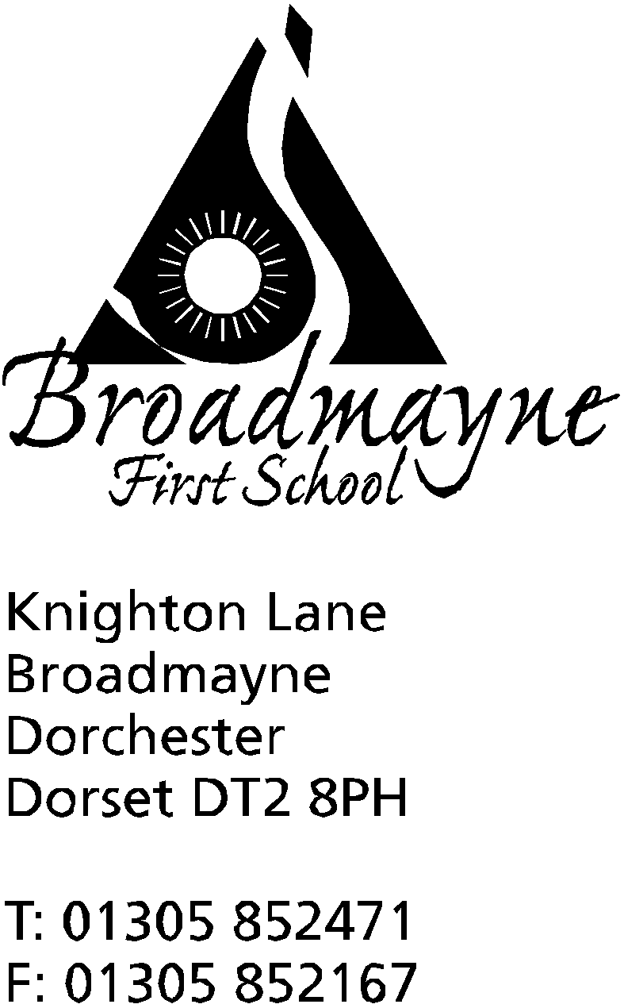

In Dorset

Headteacher
Helen Collings
Thursday 5th November 2020

Autumn 2020: Newsletter Number 8

Things to remember!
- Trevor Senior’s lunchtime Football Club for KS2 children begins tomorrow
- Wear Red for Poppies tomorrow- wear something red to school and bring a donation for the Poppy Appeal
- Please ensure you have logged on to give your permission for the flu vaccinations (email with link sent previously) - currently this is still planned to take place on 16.11.2020
- Please note-we are still able to have the school photographer in but the day has changed to Monday, 9th November.

Dear Parents and Carers,

There has been something of a change to our world yet again since I last wrote to you all. The announcement of a second lockdown took us all by surprise, and I have been waiting to see if any further guidance released this week would mean the school would need to make significant changes to the risk assessments we currently use.

Lockdown 2.0
Following guidance released yesterday for schools, Broadmayne is able to carry on much as we have been doing since our return in September. There will be extra restrictions on visitors to the school, although most of our usual routines and activities will continue - music lessons will still take place, and Breakfast Club and Cool Kids will still be happening. if there are any changes to any of these we will let you know as soon as possible.
Along with asking parents and carers to ensure they are wearing masks when coming on to the school grounds, staff within school will also be wearing masks in communal areas - mainly the office, staffroom and the corridor into the main part of the school.
One thing I do ask is that you ensure your children have plenty of warm clothes to wear - we are finding layers are the key here! We are keeping the school well ventilated, and as the weather gets colder this can mean that, despite the heating being turned on, classrooms will be cooler, and we want everyone to be as comfortable as possible.
We will provide remote learning for children who have to self isolate, either through COVID related illness in the family, school bubble closure, or being instructed to by the NHS/Track and Trace. This will be via Google Classroom for Years 1 to 4 and Tapestry for Reception children, and there will be emails from teachers so please keep an eye on your inbox (and junk mail, as we find they sometimes end up there). Please ensure your child is able to access Google Classroom - years 3 and 4 have recently moved to new classrooms within this. Any problems do let your class teacher know in the first instance - I am always happy to talk you through it on the phone if you can’t get it sorted!
I hope you all know that we are doing everything we can to minimise the risk for our children, staff and families, and we will do our best to remain open throughout the coming weeks.

Parents Consultations and Feedback
I will be sending out a parental questionnaire to get some feedback from you all on how you feel your child has settled back into school since September, and to find out any concerns or questions you may have (and anything you would like to tell us has gone well!). This form will also give you the option to indicate if you would like a short consultation with your child’s class teacher - this will be either online via Google Meet or via telephone. These will only be available for children in Years 1 to 4, as Reception parents had the opportunity to meet with teachers earlier this term. The consultations will be similar to the more traditional parental consultations - they will be timetabled for particular days, and will be in ten minute slots. Once we know the numbers of people signing up we will be able to share with you the dates for these.

School Logo
You may have heard from your children that we are currently looking into freshening up the design of the school logo, and currently we are consulting with all the children on their views on different design ideas. I will share the outcome of this with you all once some decisions have been made. I did tell the children not to come home and tell you that we are changing the uniform and everything needed to be thrown away and replaced - I do hope this message got through! Any new logo we decide upon will be gradually filtered through the school, and we don’t expect anyone to change any aspect of the uniform their child currently wears.

Online Performances
I am really aware that our families have been missing out on the opportunity to get together to watch our children perform in different ways, be it class or school assemblies, or school plays. With this in mind (and in the knowledge that Nativity season is approaching!), I would like to create a Broadmayne First School Youtube channel, where we could easily host video performances of our children and then share the links with you. This would be a private channel, which would not come up on Youtube searches,and of course we would not identify children in any way. It is an approach commonly used by several schools in our area. Before we do this, I would like to know if our parents support this idea. If we have a majority of parents in favour of this, I will send out a link to ask you to update your permissions for sharing your children’s images.
I have created a really short yes/no questionnaire to find out your views - please do take a minute to let me know, so I can begin to plan for future performances! The link is here: https://forms.gle/RA8qzTMykQm9ZxcZ6

FABS Update
You may have heard by now that sadly the much anticipated Bright Lights of Broadmayne has had to be postponed due to the new lockdown. For the time being can we ask you not to send any more jars etc into school - we hope to reschedule at a later date.
However, you can still help the school whilst doing your online Christmas shopping this year! Both of the following are really easy to use, and as many of us will be resorting to online shopping, could bring in some much needed funds for the school:
https://www.easyfundraising.org.uk/causes/friendsatbroadmayneschool/
You can download the app, or the add-on for your internet browser and can get cashback for FABS when shopping at eligible websites.
https://smile.amazon.co.uk
Every purchase you make the school get 0.5% donation from Amazon!
Also, please don’t forget the Splash Lottery - better odds than the National Lottery with a guaranteed prize for a Broadmayne Supporter each week and an entry into the national jackpot draw where you could win £25,000. Tickets from £1 per week and all monies raised go directly to supporting the refurbishment and ongoing upkeep of the swimming pool.
https://www.yourschoollottery.co.uk/lottery/school/broadmayne-first-school

As we move into a second lockdown, I would like to reassure you all that we are here, as always, to support our children and families. If there is anything you are worried about, or any help we can provide for you, please do not hesitate to get in touch. I firmly believe that our strong school community is what helped us get through the first lockdown, and meant we had a successful return to school in September, and we are determined that this will continue over the next few weeks. We may be in different boats, but we are all trying to navigate the same storm, and by working together to support each other I know we can do so in as positive a way as possible.
Yours faithfully,

Mrs Collings

Calendar Dates- Autumn Term 2020
Date | Time | Event
NOVEMBER 2020
Friday 6th |  | Wear Red for Poppies - suggested £1 donation
Monday 9th | 9am | School photographer visits to take pupil photographs
Friday 13th |  | Children in Need - wear stripes and or spots - bring a donation
Monday 16th |  | Flu Immunisations clinic
Monday 23 - Sunday 29th |  | Online auction for FABS - come and grab a bargain!
DECEMBER 2020
Wednesday 16th |  | LFL Christmas Lunch
Friday 18th |  | Christmas Party Day and last day of Autumn term
Monday 21st to Friday 1st Jan |  | Christmas holidays
JANUARY 2021
Monday 4th |  | Return to school for beginning of Spring term

