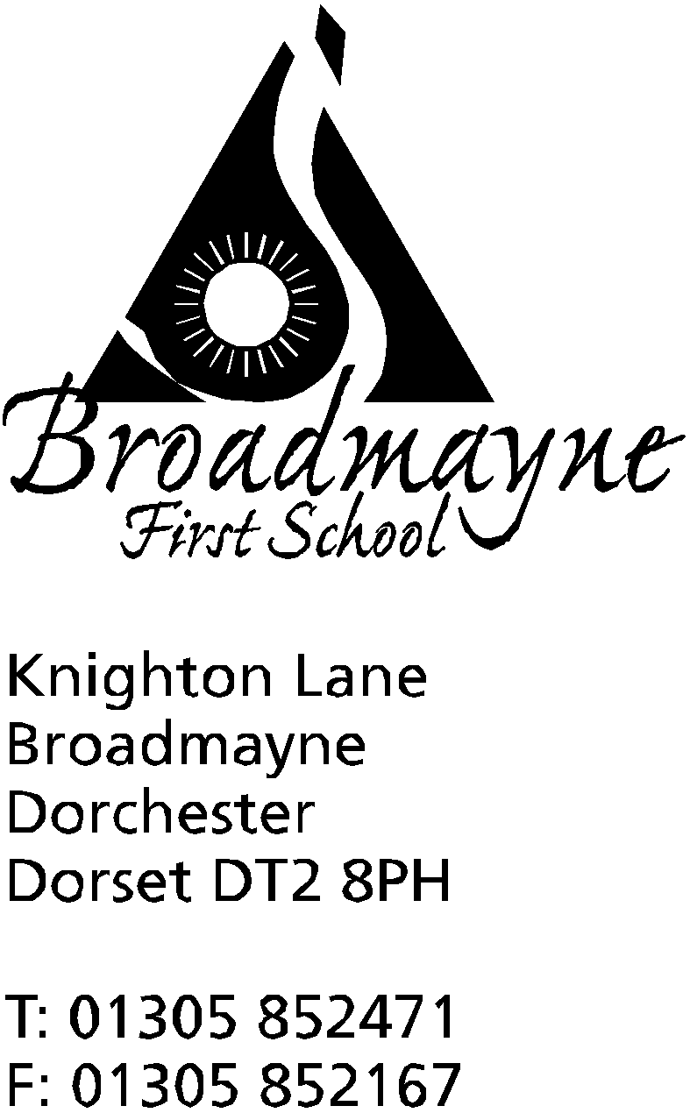

In Dorset

Headteacher
Helen Collings
Tuesday 5th March 2019

Spring 2019 - Newsletter 5

Things to remember:
- Return parent/carer consultation forms
- Books at Bedtime- Tuesday 5th 5.30 pm start - parents, bring a book to swap!
- World Book Day-Friday 8th March -make up a story character and come dressed as them!

Dear Parents and Carers,

After a warm start to the new half term, we seem to have returned to more traditional weather! Please ensure children have coats with them at school - even if there is a little rain we try to get the children outside every day, and coats with hoods or hats ensure they stay warm and dry at all times.

Nepal Assembly
On Wednesday 27th we were pleased to welcome Tony and Estelle Adams to our school. They gave two assemblies to KS1 and 2 all about their travels in Nepal, and shared lots of fascinating photos, clothing and other items with us. Due to our growing links with the Altevette project in Nepal, we are working across the school to develop our understanding of what the country is like, and what life is like for children living there. Thank you to Mrs Bassindale for organising this!

Toilets update - and thank you!
The school would like to extend a huge thank you to parents and friends who came in to school over half term to give the Year 1 and Reception toilets a much needed make-over. The jobs undertaken included fitting new easy flushes, moving paper towel and soap dispensers, fitting a ventilation fan and repainting the walls. They now look so much nicer, and will be far easier for the children to use.
The plumbing was undertaken by Martin Richardson, Peter Russell worked on the electrics, Gary Borthwick provided us with a decorator and Russell Partridge helped us out with sourcing a fan - thank you to you all from the staff and children!

Internet Safety
There has been a particular story about internet safety in the news recently, which has involved parents being concerned about their children seeing things via sites such as Youtube that are unsuitable for young children. At Broadmayne we teach our children about how to keep themselves safe whilst online, but it is always good to remind ourselves as parents of what we can do at home to help keep our children safe, and to keep up to date with the facts. If you are a Facebook user it is worth following the Dorset Police page, as they have lots of useful advice.
This article from parent Zone gives an overview of what has been happening recently, and helps separate fact from fiction - http://bit.ly/2GNaCjz

Defibrillator
We are pleased to let everyone know that there is now a defibrillator in West Knighton. It can be found in the red post box in the village. It is good to know that anyone can use a defibrillator - you don’t need to be trained. There are clear instruction on how to attach the pads, and the machine will then monitor the heart rhythm and only instruct you to deliver a shock if needed.

Mrs Denning
After 31 years at Broadmayne, Mrs Denning has sadly decided that the time has come to retire. We are currently advertising for someone to take over her job within school - but we could never replace her! I know there are many parents at the school who remember Mrs Denning from when they attended as children. If you would like to contribute something to the collection for her retirement gift, please give it to Mrs Foyle in the school office.

Playground Toys
Does anyone have any toys at home that aren’t being used that would be suitable for the children to use at playtimes? We are looking to replenish our toy cupboard, and are in need of items such as small, light balls, hoops, and anything that could be used for throwing and catching. They need to be robust enough to withstand the rigours of a First School playground - please let the office know if you have anything that might be suitable!

Yours faithfully,

Mrs Collings

Calendar Dates

Date | Time | Event
MARCH  Week beginning 4th |  | Book Week
Wednesday 6th | 8.50 am | School nurse drop in  YR hearing tests
Friday 8th | 9-9.30 am | School World Book Day  Read with a Relative or friend
Mon 11th | 2.45pm | Y2 parents SATS meeting
Mon 11th, Tues 12th, Weds 13th | 3.30 - 5.30pm | Parent Consultations
Friday 15th |  | Red Nose Day
Tuesday 19th | 9-10.10 am | Learn Alongside Your Child - focus on spelling and writing
APRIL  Mon 1st, Tues 2nd, Weds 3rd |  | Y4 residential trip to Hooke Court
Thursday 4th | 9.15 am | Year 2 Class Assembly
Friday 5th |  | Last day of Spring Term

