Broadmayne First School Knowledge Organiser

Literacy Focus | Reading and Writing | Year 3 | Spring Term 1

The Power of Reading |  |  | Guided Reading | Key Knowledge and Vocabulary
Tales from different cultures - Stories with a lesson  Writing  Poetry, playscript  Drama  Freeze frame, interview | 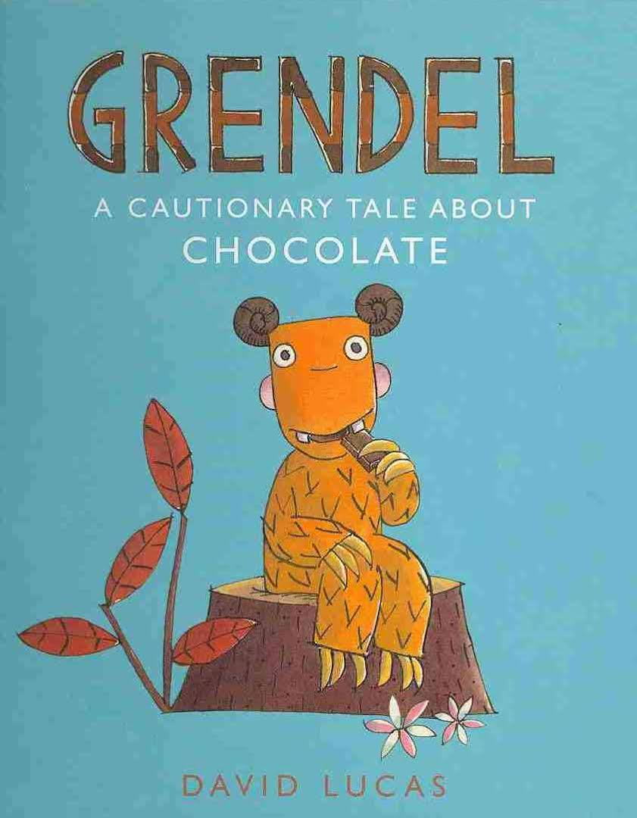  Myths - Stories with a lesson  Writing  Diary (writing in role), Story  Drama  Freeze frame, conscience alley |  | Decoding- breaking down a word into phonemes (sounds) to be able to read it.  Retrieval - finding information in the text to answer a question.  Prediction - saying what you think will happen next or as a result of something.  Deducing - using logical reasoning by applying known information  Inference - making assumptions about something based on what has been read. | Key word  Root Word  Prefix  Suffix  Spelling pattern  Fronted adverbial  Conjunctions  Clause  Beginning  Build-up  Problem(climax)  Resolution  Ending | A word which can’t be phonetically decoded - See the Year 3 and 4 Spelling List  A word to which we can add prefixes and/or suffixes, eg play -played, player  A prefix is added at the beginning of a word in order to turn it into another word e.g. disappear  A suffix is an ‘ending’, used at the end of one word to turn it into another word e.g. ing, ed  A group of letters that make a phoneme common to lots of words eg, -ture /ch/; picture, future,  Words or phrases at the beginning of a sentence, used to describe the action that follows e.g. Later that day, Angrily, As quick as a flash. Followed by a comma.  A word which can go in the middle or the beginning of a sentence and connects 2 sentences together eg ‘but, or, yet, so, and’ in the middle, ‘when, although, despite’ at the beginning.  Part of a compound or complex sentence, containing a verb and a subject (adding extra detail to a sentence)  Features of a story used to plan and write a narrative. Supports the development of character and plot.
Planned Experiences |  |  | Spelling, Punctuation, Grammar
* EXPLORATION: What makes good writing? Poetry? Narrative? instructions?  * COMPOSITION: Writing poems, writing diary, playscript, story planning - beginning, build up, problem, resolution, ending  * VISUALISATION: Creating images with words.  * COMPARISON: Cultural similarities and differences through text. Link with other stories (with a lesson)  * PERFORMANCE: Drama and Role play  * SKILLS: Using appropriate features. Writing in paragraphs. Editing and improving (in all compositions) |  |  | Prefix Meaning - negative meaning - un, dis, mis  Suffix Meaning - adding ing/ed to polysyllabic words with stressed and unstressed endings  - Double the consonant  - Just add ing/ed
The Big Write |  |  | Handwriting
Digital literacy clips (films), music and still images are used to inspire a longer piece of independent writing. The Big Write shows how you use the literacy skills that have been taught in class. The session includes some shared writing (the whole class creating some example sentences) The Big Write can be a story, a non fiction text, an explanation, a report or a poem around a specific theme. |  |  | Ascender: letters that have a stick that goes up above the line you are writing on (b,d,h,l,t,k).  Descender: letters with a tail below the line you are writing on (f,g,j,p,q,y).  Curly letters: c, e, s, x  Top joining letters: r, o, w

