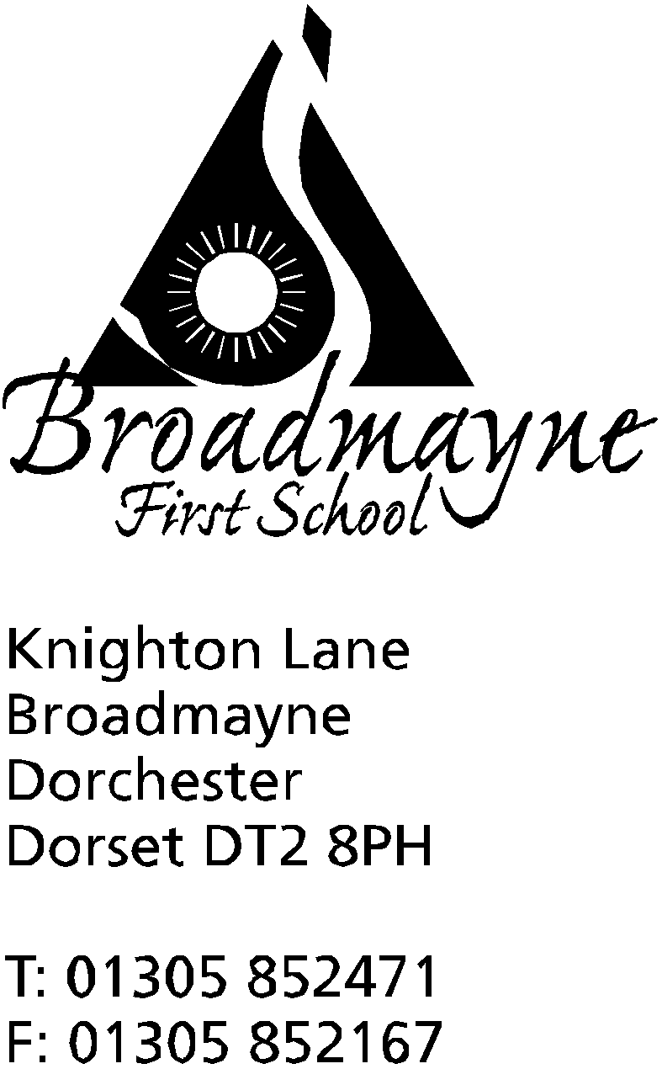

In Dorset

Headteacher
Helen Collings
Monday 16th March 2020

Dear Parents and Carers,

I am writing to you to share with you the plans the school has in light of recent developments in advice around COVID-19 (Coronavirus).

What the school is doing:
- encouraging regular handwashing and sanitising for staff, pupils and visitors
- teaching children the importance of covering their mouth when they cough or sneeze and washing their hands immediately afterwards/disposing of tissues
- reminding staff and pupils not to touch their eyes, nose and mouth
- ensuring the school is cleaned to a high standard
- making available disinfectant wipes for doors, laptops etc
- acting on all current advice from Public Health England, Dorset Council and the Department for Education

In the event of having to close or partially close the school:
We recognise that not all families have access to technology or reliable connections to the internet, and so will try not to over rely on this as a means of setting work for our children. Depending on the amount of time we anticipate being closed, we instead intend to set project based learning for the children, similar to the optional homework that is sometimes set in the different classes. We will send home paper copies of this, along with revision style work for children to complete. We understand that you may have several children at home, or they may be being looked after by other people, and we do not want to overburden either you or your children at such a difficult time.
Of course, there are online platforms the school makes use of, and these will still be available. These will include Times Tables Rockstars and Google Classroom for the older children.

What parents and carers can do:
- talk to your child about the importance of personal hygiene
- contact NHS 111 if you require advice regarding COVID-19
- follow current government advice on self isolation
- Inform the school if you or anyone in your family are self isolating

We are not currently anticipating closing the school, but as can be seen in other countries, the situation may change rapidly, and we all need to be prepared for this. We would request your support in working with us to ensure our children feel safe during this unprecedented period.
Yours faithfully,

Mrs Collings

