BFS Knowledge Organiser Topic Maths Yr 2 Autumn 1
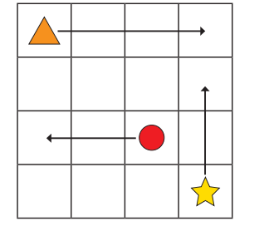
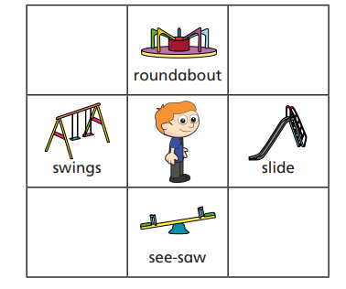
Patterns | Position, movement and turns
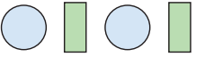  2 shapes in the core pattern that can be repeated.  3 shapes in the core pattern that can be repeated | Using words such as  forward, backwards and  left, right, up and down to  state the position of an  object.  Using words to describe  movement forwards,  backwards a number of  squares from one point to  another.
Vocabulary for patterns and sequences.

Order - shapes or objects laid horizontally or vertically in a specified way
Core - 2 or 3 shapes or objects that can be repeated in a pattern
Repeat - the core pattern or set of objects that is used over and over again
Ordinal numbers 1st, 2nd, 3rd, 4th etc - the position of a shape or object in the pattern
Rotation - Turning a shape or object to a different orientation.

Vocabulary for position, movement and turns

Forwards
Backwards
Up
Down
Left
Right
Clockwise
Anti-clockwise
Rotation  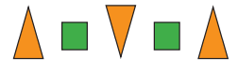  A shape is turned to face a different direction. | 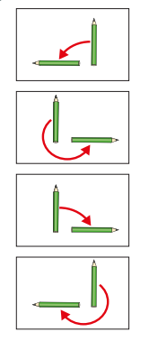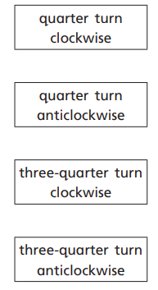
Looking for patterns in nature and those made by others. Creating patterns using natural objects.
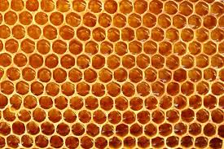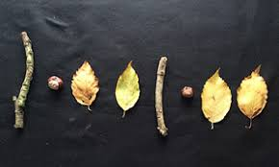
Printing patterns in art using sponges, cotton reels etc and paint.

