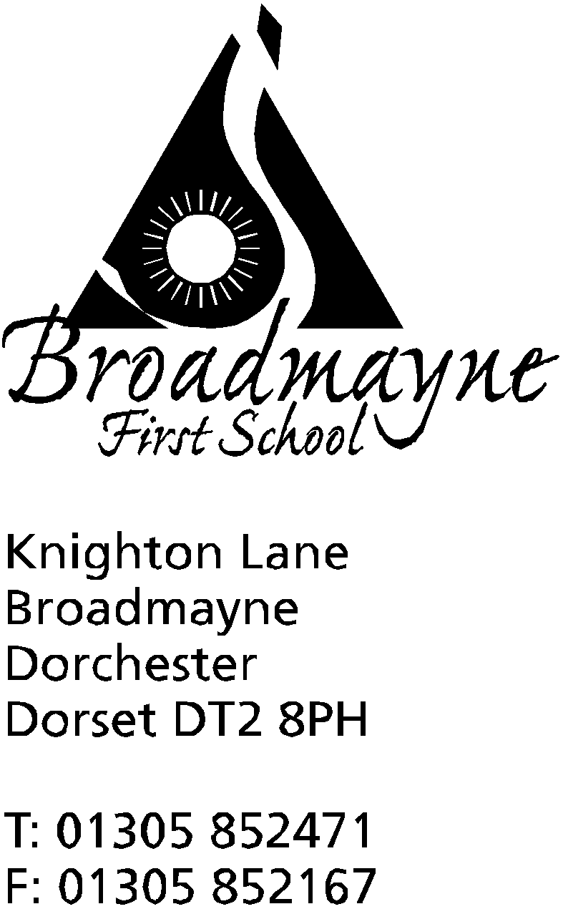

In Dorset

Headteacher
Helen Collings

Tuesday 16th October 2018

Autumn 2018: Newsletter No. 3

Things to remember!
EYFS Workshop today, Tuesday 16th 7-8 pm
Read with a Relative 17th October 9am - 9.30 am
Lunch orders for after half term need to be completed
Flu Immunisation forms must be returned by 6/11/18

Dear Parents and Carers,

We have had a busy half term and are all looking forward to our imminent break. As I begin this letter today the sun is shining, but the forecast looks as if winter might be on its way! Please can you ensure children have coats for play times from now on - and make sure they are clearly named, it’s surprising how many children mislay them.

Harvest Festival
Thank you so much for coming along to our Harvest festival, and for all the donations of food and toiletries for the local Food Bank. We were sad that Steph Jenner, our local Methodist minister, was unable to join us, but very pleased that Mrs Austin was back in her her rightful place at the piano! Thanks to your generous donations we were able to deliver lots of boxes of food to the food bank in Dorchester.

LIfe Education Van
Last week all the classes enjoyed visiting the Life Education Van, where they met Harold the giraffe, and learned all about their bodies and keeping healthy. We will continue to follow up these lessons throughout the year.

EYFS Workshop
Don’t forget that Mrs Bostock and Mrs Stoker will be running an evening workshop with information about the Early Years Foundation Stage curriculum for those parents with a child in the Reception class. This will be from 7- 8pm today, Tuesday 16th October.

Attendance
Please take a moment to read the letter from DASP about attendance. All schools in DASP follow a common commitment to reducing absence within our schools, and requests for term time holidays will not be authorised unless they are considered to be for exceptional reasons.

Photos
The school photographer will be visiting on Friday 2nd November for individual portraits. There will also be a session for family photos on Monday 19th November. Booking forms for this will be sent out nearer the date.

Read with a Relative or Friend
On Wednesday 17th October we will be holding a ‘Read with a Relative or Friend’ session. This will begin at 9am and finish at 9.30am. Please meet in the hall beforehand, to give the children time to settle into class and have registers taken. This is a lovely opportunity to drop in and spend some time reading with your children - you may find others join in as well! If you would like to bring a favourite book that would be most welcome - we are really trying to promote the love of reading amongst the children, and this is a great way to do it.
There will also be a Learn Alongside Your Child session on November 2nd. This will be a maths session, and a chance for you to come along and see some of the methods your child has been using in class.

Reading Shed
The Reading Shed is nearly ready for its grand opening! We have insulated it, covered the walls, and Mrs Denning has planted up the window boxes. Now we need your help to finish it. Do you have any spare cushions you could donate to us - floor cushions and bean bags would be most welcome! We are also looking for a small bookcase and a rug for the floor, and any unwanted children’s books in good condition. Please let the school office know if you can help out!

Pizza Day
We will be holding a whole school pizza day on Friday 19th October- weather permitting!

Parent Consultations
A big thank you to all the parents who came along, and to staff who stayed to meet with them all for our Parent Consultations last week. I hope that you have all now had the opportunity to speak with your child’s teacher, discuss any concerns, and celebrate successes. If you didn’t get the chance to come in, please contact the school office or the class teacher directly, and an appointment will be organised for you.

Snapshot Reports
The school is trialling a new short report to parents, which we intend to send out each half term. It will report to you on your child’s attitude to learning within the classroom, which is the question we find parents most frequently ask us. We would welcome any feedback on this - we are hoping it will be useful information for you.

Clubs
We tend not to run too many clubs in the second half of the Autumn term, as we find it doesn’t take many weeks before it gets too busy to continue them!
Gym Club with Mrs Howells will continue a little longer - a letter will be sent out to the children who currently attend.
Mrs Norman will be starting a lunchtime Reading Club - details to follow!
Ms Carter will be holding a lunchtime Homework Club for Key Stage 2 children on Wednesdays, and a Mindfulness Colouring Club on Tuesday lunchtimes - no need to sign up, children can just attend if they wish.

Football
A Football Contract has been sent home for children in Years 2,3 and 4 who would like to play football at break times. Please could you read this through with your child, and then sign and send it back if your child would like the opportunity to join in.

Altevette
Thank you so much for your donations of warm winter clothing to the Altevette Project. Linda picked up the items on Monday 8th, and flew out to Nepal that evening. She has asked us to send her heartfelt thanks, and will be sharing photos of her trip with us, which we will add to the school website.

Thank You
A big thank you from the school to Martin and Hayden of Richardson Plumbing and Gas Ltd, who gave up a Saturday morning to come and help us out with plumbing in a new toilet. They did a fantastic job, and the staff are very pleased they have a stylish and fully functioning new loo!

FABS
The FABS held their AGM on Monday 8th October. It was lovely to see some new faces at the meeting, and I look forward to working with everyone in the future. There were some great ideas for fundraising events, which FABS will share with the school community. I know they are looking for people to help out, so please watch their board in the school office for information.

We wish you a happy and relaxing half term, and look forward to welcoming the children back after the holiday. Remember Monday 29th October is an INSET day, and children return to school on Tuesday 30th.

Yours faithfully

Mrs Collings

Date | Event | Time
OCTOBER
Tues 16th | EYFS Curriculum meeting | 7-8 pm
Weds 17th | Read with a Relative or Friend | 9 am
Fri 19th | Whole school and Pre-School Pizza Day
Mon 22nd-Fri 26th | HALF TERM
Mon 29th | INSET day
Tues 30th | Back to school
NOVEMBER
Fri 2nd | Individual photos
Mon 5th - Fri 9th | Remembrance Week
Tuesday 6th November | Learn Alongside Your Child | 9am
Thurs 8th | School Nurse Drop In | 8.50 am
Mon 12th | Beginning of Anti-bullying fortnight
Weds 14th | Flu innoculations - optional
Fri 16th | Children in Need (further details to follow from the School Council) | 9.00 am
Mon 19th | Family Portraits
Tues 27th | Year 3 trip to Bovington Museum
DECEMBER
Mon 17th | Christmas play in school hall | 1.45 pm
Tues 18th | Christmas play in Broadmayne Village hall  “ | 9.30 am  6.00 pm
Fri 21st | Last day of term; Christmas party lunch
Mon 7th Jan 2018 | First day of Spring Term

