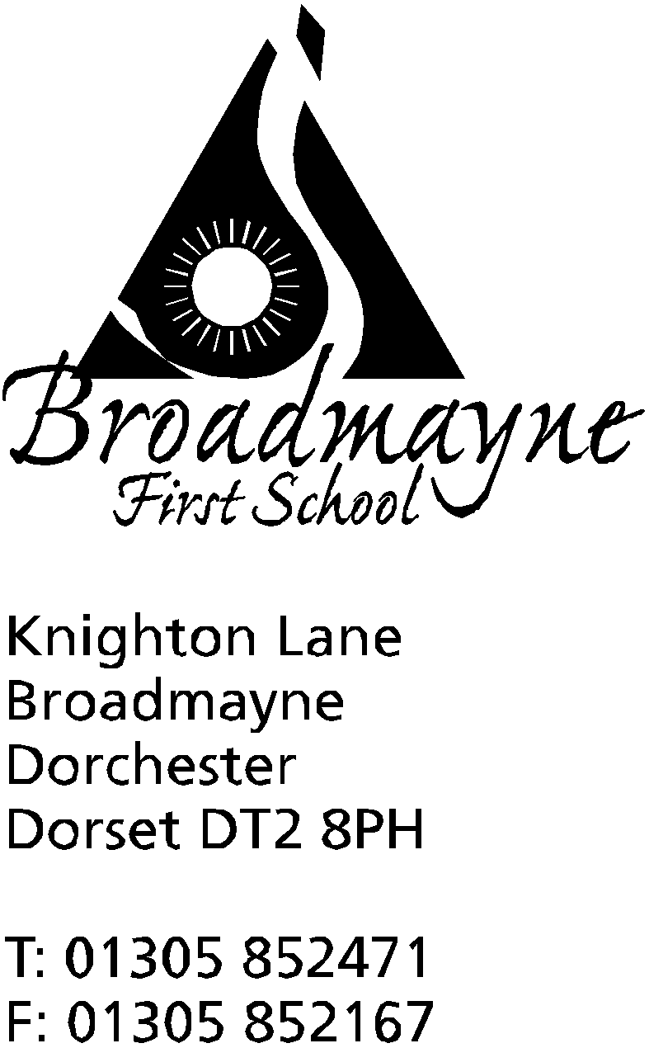

In Dorset

Headteacher
Helen Collings
12th February 2020
Spring 2020 - Newsletter 4

Things to remember:
- Years 3 & 4: Have you returned your photo permission form for Kingston Maurward?
- Have you bought your ticket for the school disco on Thursday 13th February?
- Don't forget, this Friday - the 14th - is an INSET day
- Dance Club will continue for existing members after half term: 24/2/20, 2/3/20 9/3/20

Dear Parents and Carers,
It seems unbelievable that we are already half way through the school year! We have had a busy half term, that has passed by so quickly - Christmas seems a long time ago!

Children’s Mental Health Week/PANTS Week
Many thanks for all your support during our PANTS Week. The children were very excited to meet Pantosaurus on Monday, and hopefully they have all learned some very important messages about how to keep themselves safe.
Throughout last week we focused on the mental health of our school community, and how we could all ‘find our brave’. The children’s mental health workshop was well attended, and we aim to offer at least one more in the summer term.
Number Day
Thank you to everyone who came in dressed as something to do with numbers last Friday - we were amazed by the inventiveness of some of your ideas! We had a great day celebrating maths, and raised over £150 for the NSPCC - a huge thank you to everyone who contributed!
Thank You!
We would like to say a big thank you to all the parents who have taken the time to bake cakes and biscuits to help raise funds for the planned Year 1 classroom refurbishment. Thank you also to those Year 4 children who have been helping out with setting up and selling the cakes - it’s very much appreciated!
Staffing
We have sadly said goodbye to Mrs Treviss today, as she leaves us to set up her own business - we wish her the best of luck with this - we know she’ll be brilliant!
We are really pleased to welcome Mrs Dawn Cornell to the school as TA for our Reception class. Dawn comes to us with many years experience of working in schools, and we are looking forward to working with her.
Fair Trade Cafe
Our annual Fair Trade Cafe will be running during the first week back after half term, from Tuesday 25th February until Friday 28th. Each class will have the opportunity to visit throughout the week, and they will be able to have a snack and a drink prepared by our Year 3 children using all Fairtrade ingredients. In order to support the cafe we are asking for a donation of £1.50 per child, payable through School Money - this will cover the cost of ingredients.

Dorchester Science Festival
The Family Science Fair, part of the Dorchester Science Festival, will be held on Sunday the 15 March from 1pm-5pm.Due to the popularity of this event last year, admittance this year will be by ticket only.
Tickets are FREE and can be obtained by going to the Dorchester Tourist Information Centre in person to collect (this is located in the Dorchester Library, Charles Street, DT1 1EE). There will be 2 time slots available – from 1pm-3pm and from 3pm-5pm. Tickets will be available from 15 Feb on a first come first served basis – keep an eye on the Facebook page for updates.
www.facebook.com/DorchesterScienceFestival
In addition, the bug and exotic animal handling activity with World-Life will also require a ticket – which can be obtained when you collect a ticket for the Family Science Fair.
Coronavirus
It has been hard to escape the news about the spread of the Coronavirus in China. The school is following DfE guidance-current advice to parents is as follows:
Coronavirus – Advice for parents/guardians
Public Health England and the Foreign Office have issued advice for anyone travelling to the area. This can be found at:
https://www.gov.uk/foreign-travel-advice/china
https://www.gov.uk/government/news/wuhan-novel-coronavirus-and-avian-flu-advice-for-travel-to-china
You should not be unduly worried about the possibility of your children catching the Coronavirus.
There is no reason why your children should not continue to attend their early years, school or further education setting as normal. We recognise that some families or children may be planning to travel to China during the forthcoming half term period. If so, please refer to the FCO’s latest travel advice via the link above
We will, of course, continue to reinforce the message of ‘health hygiene’ with our children - using tissues, washing hands etc..
Science Capital
Calling all Drs, Nurses, Vets, Engineers, Data specialists - We would like to hear from anyone in our community who has a STEM related job. We would be keen to invite you into school next half term to talk to our pupils about it, and share your passion and enthusiasm for your specialist area. It's never too early to inspire pupils about their future, and we recognise our responsibility to promote this industry, which will require an increasing number of employees from our pupil's generation. If you, or anyone you know would be keen to visit our pupils, please contact the school office.
Charity Fund Raising
Two of our families are currently raising money for good causes:
Esme Yeoman and her mum, Pippa, are raising money for LATCH, the Welsh children’s charity for cancer and leukaemia. Esme will be selling some of her crafts after school - details to follow- and Pippa will be running the Manchester Marathon to raise funds - details of her Just Giving page can be found here: https://www.justgiving.com/fundraising/pippa-yeoman
Lexi Nelmes is aiming to raise money for The Little Princess Trust and The Lexi May Trust, by cutting off her hair on the 29th February!
https://uk.virginmoneygiving.com/SarahNelmes1

Wishing you all a happy and relaxing half term, and looking forward to seeing everyone back at school on Monday 24th February,
Yours faithfully,

Mrs Collings

Calendar Dates- Spring Term
Date | Time | Event
FEBRUARY
Thursday 13th | 9.15 am  5.30pm-7pm | Year 1 Class Assembly  FABS school disco
FrIday 14th |  | INSET DAY
Monday 17th - Friday 21st |  | HALF TERM
Monday 24th |  | Return to school
Tues 25th - Fri 28th |  | Fair Trade cafe
Tuesday 25th | 5.30pm | Full Governing Body meeting
Thursday 27th | 8.45am  2.45pm | School Nurse drop in followed by YR hearing tests  Hooke Court Meeting for parents
MARCH
Tuesday 3rd | 5pm | Hooke Court meeting for parents
Wednesday 4th | 6pm | Year 4 DASP Concert at THS Theatre
Thursday 5th |  | World Book Day - details to follow
Mon 9th - Fri 13th |  | Sports Relief Week
Thursday 12th | 9.10am | Year 3 Assembly
Mon 23rd and Tues 24th | 3.30 - 5.30pm | YR parents consultations
Tuesday 24th | 5.30pm | Full Governing Body meeting
Friday 27th |  | Written reports sent home
Mon 30th - Fri 3rd |  | STEM WEEK - Exploration and Discovery
APRIL
Wednesday 1st | 9.10am | Year 2 Class Assembly
Thursday 2nd |  | YR trip to THS for a Rocket Workshop
Friday 3rd |  | FABS Easter Egg Bingo  BREAK UP FOR EASTER HOLIDAYS
Monday 20th |  | Return to school

