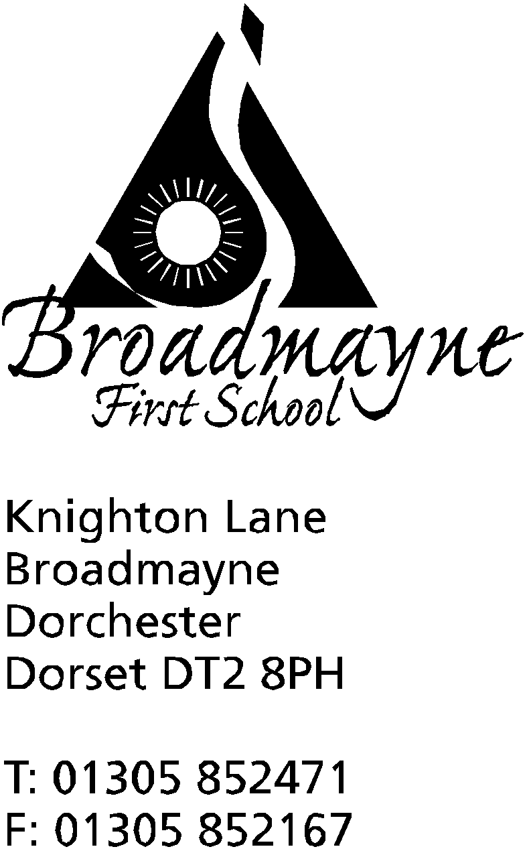

In Dorset

Headteacher
Helen Collings
Tuesday 25th August 2020

Autumn Newsletter 1

Dear Parents and Carers,

I hope you have all had a happy and relaxing summer holiday, and were able to make the most of the good weather we had at times - I managed to experience camping in North Devon during the wind and rain towards the end of August - something I’m not likely to forget for quite some time!

The purpose of this early newsletter is to share with you all our plans for starting back to school in September. We are looking forward to welcoming all our children back, and to meeting our new Reception children, and have planned to make school as ‘normal’ as possible, whilst also doing our best to minimise risk for our children, staff and families. These plans have not changed in any great detail since I shared them with you in the last newsletter I wrote, but if you are like me you may well have mislaid this letter since the beginning of the holidays!

Our Return in September
- There will be an INSET day on Tuesday 1st September, and Years 1 - 4 return to school on Wednesday 2nd September
- school uniform must be worn from September onwards
- The one way system we currently run for entering and leaving school will continue - this will be well sign posted and staff will be outside to guide you for the first few mornings! Please use the one way system around the school when dropping off or picking up children - I know this is a little inconvenient at times but it has worked well during lockdown and will enable us to support you in social distancing
- There will be staggered drop off and pick times in order to ensure families can social distance as necessary. The times and routes are as follows:

Drop off and pick up times
Class | Drop off | Pick up | Route
Reception | 8.45 - 8.55 am at YR door | 2.55 - 3.05pm from YR playground | Through car park following one way system
Year 1 | 9 - 9.10am at door in Secret garden | 3.05 - 3.15 pm from Secret Garden | Through car park to Y1 fire door, follow one way system
Year 2 | 8.45 - 8.55 am at hall door | 2.55 - 3.05pm from playground | Follow one way system, using Y2 /hall door
Year 3 | 9 - 9.10am at usual Y3 door | 3.05 - 3.15 pm from playground | Follow one way system using Y3/library door
Year 4 | 8.45 - 8.55 am at Y4 fire door around the back of the classroom | 2.55 - 3.05pm from playground | Follow one way system to Y4 fire door

- please send children into school with PE kits- these will remain in school until half term - this does not apply to Year 1 who will be asked to come in to school wearing their PE kit on the relevant days - Mrs Bassindale will send further information on this
- we will contact you at the beginning of term to explain how the reading system will work for the time being
- the school will provide hand gel for all classes to use - we will be asking you to sign a permission form for for this if you have not already done so
- there will be no hot school meals provided for at least the first four weeks of the autumn term - please either send your child in with a packed lunch, or one can be ordered via the Local Food Links website- we will inform you once we feel hot school meals are a viable option for us
- other than PE kit, bags, lunches and coats, we ask children not to bring anything else in to school
- please note we operate as a nut free school as we have several children with severe allergies
- please do not send children in to school if they are showing any symptoms of coronavirus - specifically a high temperature, a persistent new cough, a loss of taste or smell.

Before and After School Care
As a school we recognise that many of our parents need to get back to work, and will require before and after school care for their children. BASE Club, Cool Kids and Breakfast Club will resume on Monday 7th September, following their usual hours of operation: 7.45am - start of school for Breakfast Club, and end of school - 6pm for Base Club/Cool Kids- please book during the first week back to school if you have not done so already.
- bookings for Breakfast Club can be made through the following form: https://forms.gle/BMX1ZKUmA8rn2krg7

- bookings for Cool Kids (which operates on a Thursday) can be made here: https://forms.gle/cP2A9XdUFKu9GJQM6

- Base Club needs to be booked directly with Jackie Naylor on 01305 852995

All clubs will run on a similar basis to the social distancing and hygiene rules we have in place for the rest of the school, and we have robust risk assessments in place which we regularly review. We will use the larger, key stage bubble approach to enable us to offer wrap around care.

Our approach is very much to try and reflect how we see the world outside of school - our emphasis is on good hygiene and social distancing where appropriate, particularly between adults. We will work to strike a balance between minimising risk for everyone at school, whilst also supporting our children’s, staff and families’ well being.

We will be operating a bubble system as we did during lockdown, but with larger bubbles within the school. Most of the time children and adults will work within class bubbles, but there will be times when we use larger, key stage bubbles, for instance in order to allow us to operate before and after school care, and playtimes. There will be regular cleaning of shared areas and equipment, and playtimes and lunchtimes will look a little different at first, with children eating in classrooms and playing in designated areas. We expect to offer a full curriculum, with an emphasis on recovery, reconnection and the outdoor curriculum as we all get used to being back together in school.

It is worth noting again, that all this is subject to change. It is possible plans may need to be changed at short notice due to further advice from the government, or Public Health England. We will always try to keep you fully informed as we learn of any new developments.

Finally, I would like to say how much we are looking forward to welcoming everyone back to school next week. It has been a strange few months, and we can’t wait to see our children and families again!

Yours faithfully,

Mrs Collings

Calendar Dates- Autumn Term 2020
Date | Time | Event
SEPTEMBER 2020
Tuesday 1st |  | INSET DAY
Wednesday 2nd | PM | First day of new academic year for Years 1-4  Transition afternoon for YR children small group
Thursday 3rd | PM | Transition afternoon for YR children-small group
Friday 4th | PM | Transition afternoon for YR children- small group
Week beg.Monday 7th | AM | New Reception children start Autumn term

