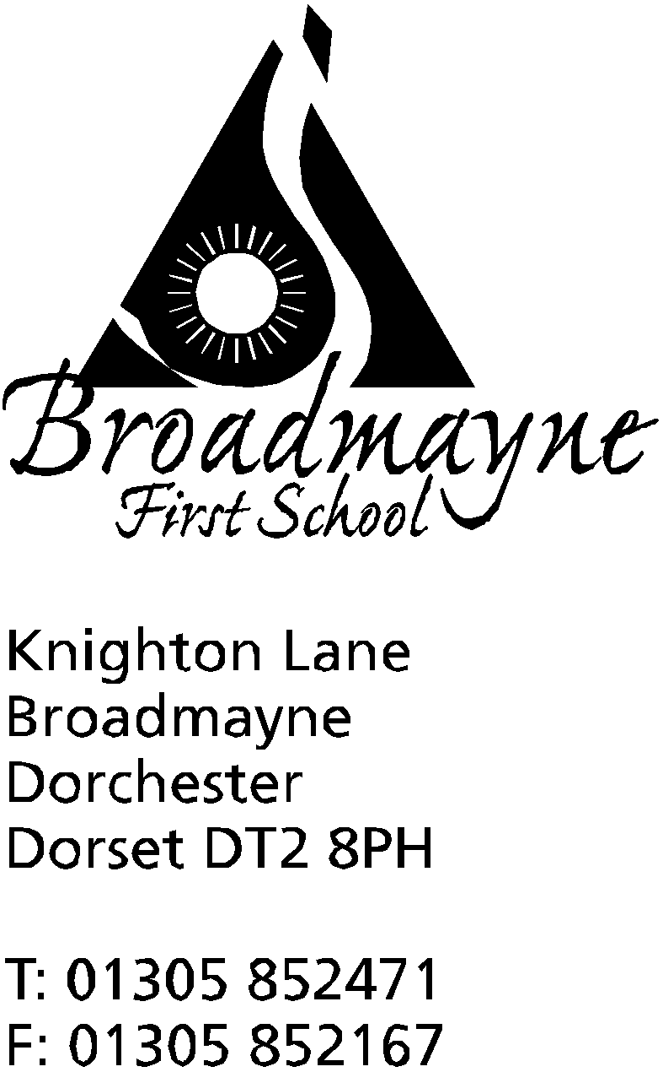

In Dorset

Headteacher
Helen Collings
Thursday 19th March 2020

Dear Parents and Carers,

At midnight last night, the government released the list of who they define as key workers. I have had several phone calls about this today, so am writing this letter in the hope of clarifying the school’s position with this.

Following on from my letter yesterday seeking identification of children of key workers who may require child care, the list now released by the government can be found here: https://www.gov.uk/government/publications/coronavirus-covid-19-maintaining-educational-provision/guidance-for-schools-colleges-and-local-authorities-on-maintaining-educational-provision

Can I stress that the school is closing today, and when we reopen on Monday it is as a childcare facility only, and there will be no structured academic learning taking place. We are here to provide a service to support frontline workers in order to ensure the safety of our wider community. It is safer for children not to attend school, and I would strongly urge you to arrange alternative child care wherever possible, particularly if only one parent is a key worker, or you are working from home. Please, only request child care if there is no other provision available to you.

We will only be able to provide child care for those days you are actually working, so please let us know what your current work pattern is. I understand things may well change but the school needs this information to plan staffing levels.

If you are working in educational settings yourselves, I would strongly suggest your children accompany you to your own school, as staff here are doing. We are trying to limit social interaction as much as possible, and it makes sense for school staff to be taking their children to their own schools if/when necessary.

Vulnerable pupils, including those with EHCPs have been contacted separately.

We have been asked to provide child care during the Easter holidays for children of key workers (not vulnerable or EHCP children) and we are happy to do this as well. We anticipate numbers will be much lower for this, as we expect parents to have organised child care in advance for this time.

School will be open from 8.30am - 4pm each day. Lunch will be provided but no other food.

It is not mandatory for schools to provide this service, and I know you all recognise we are putting the importance of caring for your children above the health of our staff and their families. At Broadmayne we know you are putting your essential job ahead of your health and that is why we are willingly supporting you with this.

In this time of uncertainty, as we move forward it is possible that we may be unable to maintain this service. We will do all we can as a school but ask for your understanding if there are periods of time when we are unable to open.

Please think very carefully about whether you need us as support for your childcare; I am concerned that as the key worker list is so broad that the school will not be able to manage all the requests. There is guidance for the school on the amount of children we can take that will still enable us to remain as safe as possible with regards to infection control; if we receive too many requests I will be forced to either prioritise or send children to a local ‘hub’, which means they will have to attend another school or setting, with different staff - I am unable to give more information on this at the moment.

Once again, if you believe you are a key worker and you cannot arrange any child care for your child, please use the following links to inform us:
by emailing the school on office@broadmayne.dorset.sch.uk
by telephone on 01305 852471
By filling out the short form which can be found here: https://forms.gle/MnsCAYJzez5b82189

The school may be asking for proof of your role.
I will contact parents by the end of today if they have requested the school’s help with childcare.

As always, our arrangements are subject to change, but I will continue to my best to plan ahead and keep you informed.

Yours faithfully,

Mrs Collings

