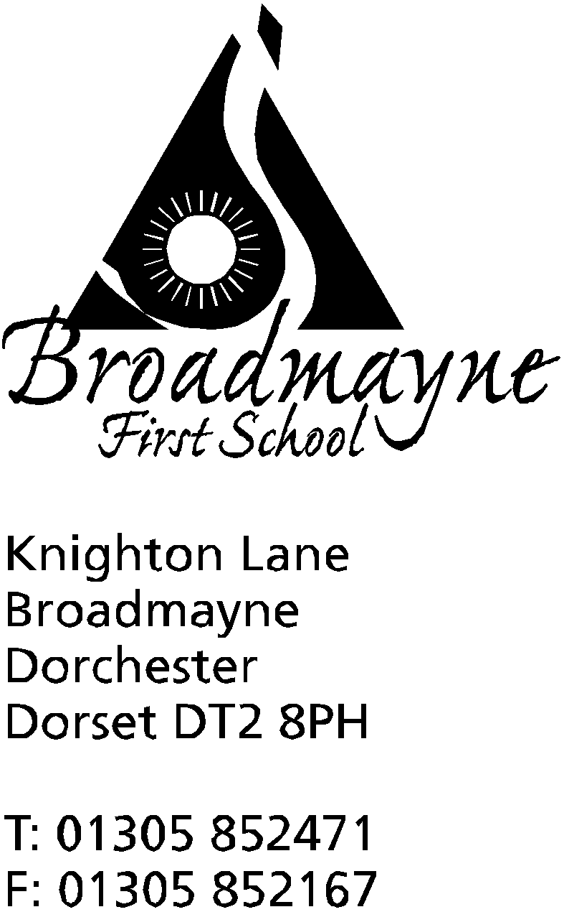

In Dorset

Headteacher
Helen Collings
Tuesday 23rd June 2020

Dear Parents and Carers,

As we move through the summer term, it has been a pleasure to be able to look out my office window and see children playing outside on the school playground - it really brightens up my day, although it also reminds me of all the children at home who we are really missing! I am writing this newsletter to share with you what the school has been doing to try and plan for the rest of this term.

Return of other year groups
Since the government changed their guidance for schools and supported the return of other year groups where possible, the school has tried to find ways in which to return children other than Years 1 and R, and our key worker children. Unfortunately, due to the size of our school and the restrictions around the number of children we may have in a ‘bubble’, we are limited in what we can offer beyond what we already do. Every school is different in this respect; some are unable to offer any further wider opening whereas others have much more space and staff available.
Because of this, we have decided to concentrate our planning on giving our Year 4 children the opportunity to have some time in school in order to be able to say a proper goodbye. We recognise the importance of transition for these children, and we know that saying goodbye is a hugely important part of this process. We want to give our children the chance to do this, whilst staying within the guidelines of social distancing and the school risk assessments. I really hope that parents of children in other year groups understand how hard we have thought about this decision. I will write separately to the Year 4 parents and carers to let them know of our plans.

New Reception Families
We are disappointed as a school at how limited we have been in being able to offer transition activities to our incoming Reception children. We are currently planning how we can manage this in September, whilst not knowing what the guidance will be around groups by then. In the meantime I will be writing to our new parents and carers with the offer of some (socially distanced!) meetings at school and online.

Home Learning
We are continuing to work on producing home learning that mirrors what is being taught within school. Staff are now in school full time, and so don’t have the time to manage emails in the same way as previously; please bear this in mind when contacting them.
All year groups apart from Reception are using Google Classroom, and it really is worth taking the time to get used to this - it is a great way to keep in touch with both teachers and other children in class, and is likely to be a platform we will continue to use in the future.

End of term
The school will be closing to all children, including those of key workers, on Thursday 16th July.

Looking forward to September
It is very difficult to plan either for the rest of this term or for September as at the time of writing the school has had no new guidance in either respect. There is talk that the government is going to relax the 2 metre distancing rule but we don’t know if this will definitely happen, or what the implications for schools will be, if any. As headteacher I feel I need to give you all as much information as possible with enough time to act on it, and I hope that you all understand that this is often very difficult, and the things I would want to do to support our children I am often unable to do so because of the various guidance we receive.

In light of all these uncertainties, the school has decided that we will not be moving our teaching staff to different year groups this coming academic year - all teaching staff will remain as they have been this year.

We fully expect to keep to our original plans for the beginning of the academic year, which means that there will be an INSET day on Tuesday 1st September, followed by Years 1 - 4 returning the next day. The two week October half term from 19th - 30th October currently remains unchanged.

Suffice to say, this is not how I ever expected our Summer term to end! We are missing all our usual events, and what is usually a busy time for us seems strangely quiet. We will be trying to keep some traditions going - we will be announcing our DASP citizens soon and presenting those children with their awards, but events such as our Sports Days, and swimming, just cannot go ahead. We are looking forward to making up for all of this once we all return to school!

Yours faithfully,

Mrs Collings

