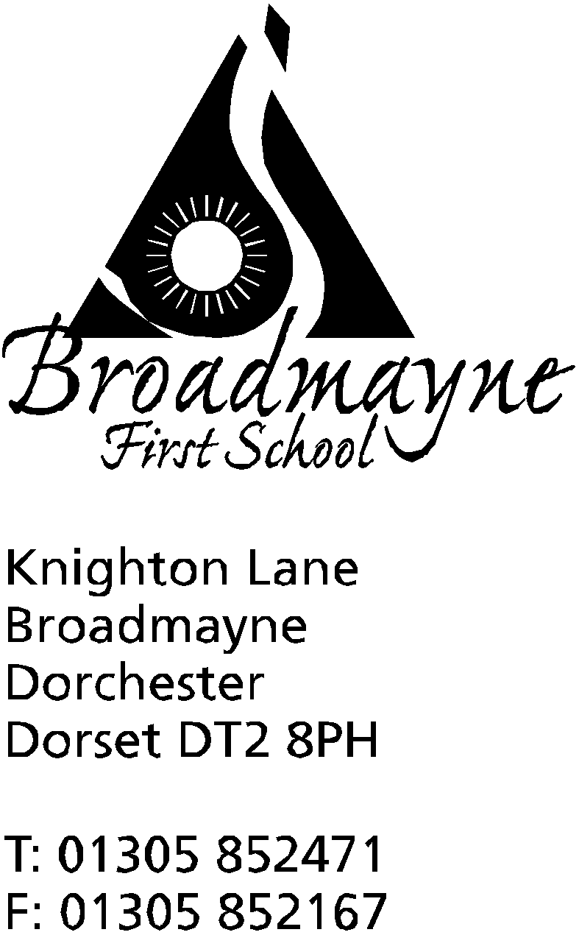

In Dorset

Headteacher
Helen Collings
Monday 11th May 2020

Dear Parents and Carers,

I am sure that after the Prime Minister’s statement last night there are many questions you will have - as a school there are many that we have too! Unfortunately, as we have only just seen the announcement ourselves, we are not in a position to answer many questions at the moment.

Currently the school has not received any clarification or support to implement the new plan to reopen to some year groups. We are awaiting further information over the next few days, which will hopefully clarify the approach we will be expected to take.

I would like to reassure you all that we will not open to any year groups unless we have a clear plan, based on strong scientific evidence, that will enable us to keep our children, our staff and our families as safe as possible.

In the meantime at Broadmayne there is no change to the guidance. The school remains open to vulnerable children and the children of key workers. We will continue to provide online learning opportunities for our children who are at home, and we will continue to keep in contact with you all. As soon as we receive more information I will share it with the wider school community.

As always, please keep yourselves and your families safe, particularly in this period of uncertainty.

Yours faithfully,

Mrs Collings

