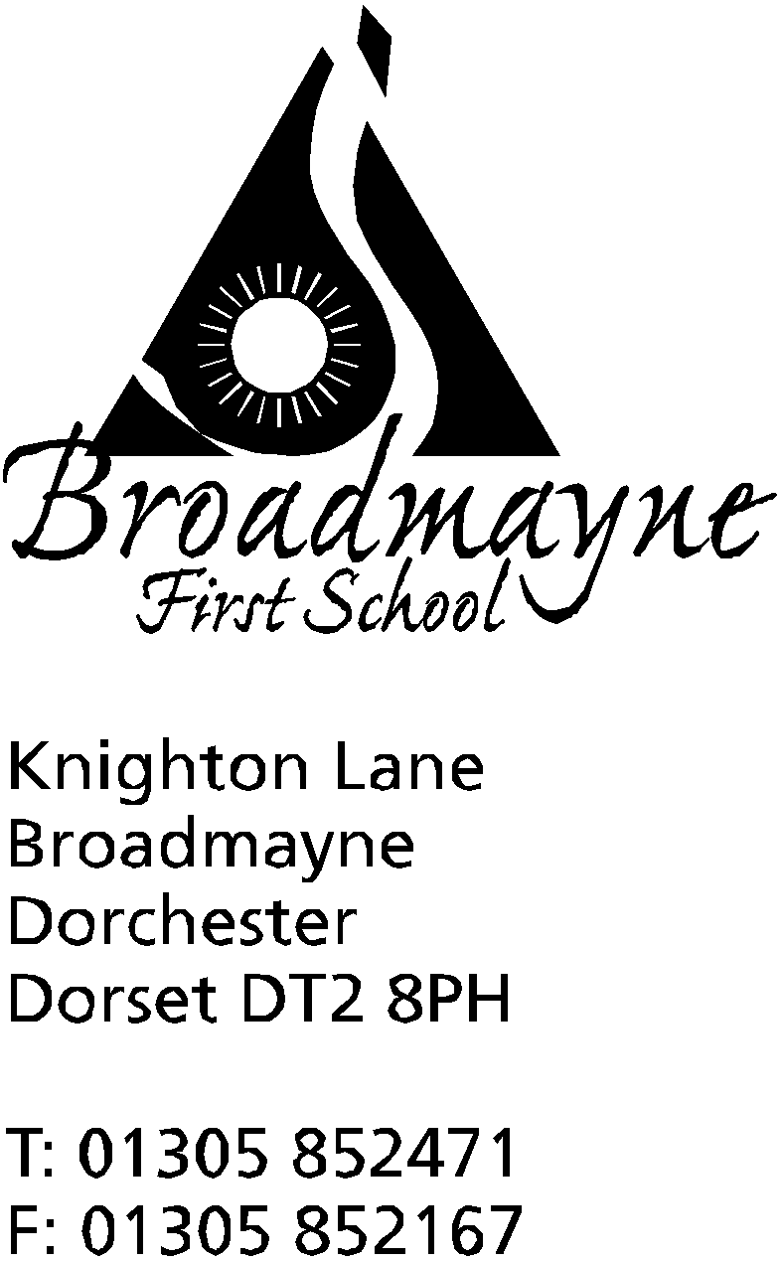

In Dorset

Headteacher
Helen Collings

Thursday 5th March 2020

Dear Parents,

Sports Relief 2020 - It's game on!

Next week is Sport Relief and we have planned some sporting activities for the children to try as well as raising money for Sports Relief.

On Monday, we are asking the children to come dressed as their favourite sports star / in sports clothes for a donation to Sports Relief. We are also hosting an assembly led by Cricket Coach, Sean Fitzgerald. After the assembly, Year R, Year 1 and Year 2 will take part in All Star Cricket sessions. If dry these will be on the playground, so the children need to be dressed warmly.

On Tuesday it’s Years 3 and 4 turn. Sean will run Dynamo Chance to Shine cricket for the older children. Please ensure your child has a warm outdoor PE kit in school.

On Thursday, Years 3 and 4 will have their last multi-skills sessions with the students from Kingston Maurward college. (Again these sessions are outside, weather permitting.)
Also, a small group of Year 1 and 2 children will be taking part in some sporty games with our new Year 4 Sports Leaders. These children recently took part in some sport leadership training.

On Friday we have a visiting tennis coach, Richard Keen, who will be running tennis taster sessions for all the classes.

Thank you for your continued support. If you have any queries, please let us know.

Yours sincerely,

Mrs V. Howells

